**Notes**

Table of Contents

Resources to learn GIT

Vocab and Acronyms

Review of Commands

1.0 What is Git

Version Control

History of Git

About distributed version control

Who should use Git

2.0 Installing Git

Installing Git on a Mac/Windows

Configuring Git

Auto-completion Set Up

Using Git help

3.0 Getting Started

Initializing a repository

Understanding where Git files are stored

Performing commit

4.0 Git Concepts and Architecture

Three-tree Git architecture

Understanding hash values (SHA-1)

The HEAD pointer

5.0 Making Changes to Files

Adding files to Git repository

Editing files

View changes in working directory

View changes in staged index

Delete files

Renaming/Moving files

6.0 EXAMPLE: Using Git with a Real Project

Initializing Git

Editing the support phone number

Editing the backpack filename and links

7.0 Undoing Changes

Undoing working directory changes

Undoing staging index changes

Undoing repository changes (undoing commits)

Retrieving old versions

Example soft reset

Example mixed reset

Example hard reset

Removing untracked files

8.0 Ignoring Files

Using .gitignore files

User-specific Ignore files

Ignoring tracked files

Tracking empty directories

9.0 Navigating Commit Tree

Referencing commits

Exploring tree listings

Viewing Commits (git log)

Viewing specific commits

Can look at blobs, trees, tags, commits

Comparing commits

10.0 Branching

Branching overview

Switching branches

Creating and switching branches at the same time!

Switching branches with uncommitted changes

Comparing branches

Renaming branches

Deleting branches

Configuring the command prompt to show the branches

11.0 Merging Branches

Merging code

Fast forward merge vs. true merge

Merging conflicts

Exploring strategies to reduce merge conflicts

12.0 Stashing Changes

Saving changes in the stash

Viewing stashed changes

Retrieving stashed changes

Deleting stashed changes

13.0 Remotes

Using local and remote repositories

Setting up a GitHub account

Adding a remote repository

Creating a remote branch

Cloning a remote repository

Tracking remote branches

Pushing changes to a remote repository

Fetching changes from a remote repository

Merging in fetch changes

Checking out remote branches

Pushing to an updated remote branch

Deleting a remote branch enabling collaboration

Collaboration

A collaboration workflow (Review)

14.0 Tools and Next

Setting up aliases for common commands

Using SSH keys for remote login

Integrated development environments

Exploring graphical user interfaces

Understanding Git hosting

15.0 Assessment

16.0 Resources

# **Resources to learn GIT**

Live demo: <https://try.github.io/>

Student pack: <https://education.github.com/>

Installation on mac: <https://www.atlassian.com/git>

Lynda: <https://www.lynda.com/Git-tutorials/Introduction/100222/111245-4.html>

Other link

* <http://gitreal.codeschool.com/?utm_source=github&utm_medium=codeschool_option&utm_campaign=trygit>
* <https://github.com/account/organizations/new?plan=free>

Vocab

Wildcard ‘*.txt’

Master name of master branch

Actions

Copy

Merge

Key commands

Things to look into

* GitHub
* Lynda Git

================================================

# **Vocab and Acronyms**

Version control System (VCS)

Source Code Management (SCM)

Central code repository model

Central Repository (CR)

Master repository

Directory

Remotes

# **Review of Commands**

|  |  |
| --- | --- |
| What it does | $ Command |
| Where am I → returns directory | pwd |
| Moves backwards in directory | cd .. |
| Brings user to computer directory | cd ~ |
| From working directory, moves files to staging index then immediately to be commited  * grabs EVERYthing from working directory. Files that are not tracked, or files that are being deleted do NOT get included  * works well for modifications, but doesn’t work well for new files and deleted files | git commit -am “commit these” |

# **1.0 What is Git**

* Keeps track of changes
* For source control management
* A version control system

# Version Control

Tracking changes

* Text changes
* Version1, version 2, version 3

* SCM is a term also used, but really means the same thing. Centered around code management

Ex of VC (non-source code)

* File naming (v1, v2, v3)
* Microsoft word → track changes
* Adobe Photoshop → history
* Wikis → rolling backwards
* Undo: control/command+z

# History of Git

1. Primitive versions
   1. Saves the whole document different times
2. Source Code Control System (SCCS)
   1. Open source
   2. Records the original doc, then takes snapshots of changes
   3. Ex: start with doc (the original) and apply 4 sets of changes
3. Revision Control System (RCS)
   1. Open source
   2. Faster: kept the most previous version, and takes snapshots of past documents
4. Concurrent Versions System (CVS)
   1. Open source
   2. Work with mult. Files
   3. More then one worker can work on the same folder at the same time
5. Apache Subversion (SVN)
   1. Open source
   2. Taking snapshots of directory (not just changes)

* so can change the names of files and track them

1. BitKeeper SCM
   1. Closed source, proprietary
2. Git
   1. Distributed version control
   2. Open source and free software
   3. Faster
   4. Better safeguards

# About distributed version control

Doesn’t communicate with a central server

* Faster
* No network access required
* No single failure point (like with the CR)
* Developers can work independently
* There is no CR that we work on (can artificially create that). All repositories =

Central Code Repository Model

* One central place → store the master copy of code
* When working with code → check out a copy from master repository
* Work/make changes with code → submit changed files back to central repository

*Up to the user to make sure that they have all the changes*

Distributed Version Control (GIT USES)

* Diff users (teams of users) maintain own repositories (instead of working from a CR)
* Changes are stored as “change sets” or “patches” → tracks change (not versions)
* More “do we apply the change set?”
* No single master repository, many working copies

# Who should use Git

Any who wants to track changes (not limited to code users)

* Review a history log of changes
* View diff b/w versions
* Retrieve old versions

Needing to share changes

Command-line tools

Useful

* HTML, CSS, JavaScript
* RHP, Ruby, Ruby on Rails, Perl, Python, ASP
* Java, C, C++, C#, Objective-C
* ActionScript, CoffeeScript, Haskell, Scala, Shell scripts

Not Useful

* Images, movies, music, fonts

** It will keep track of changes (new and old files)

** the main thing is you can’t see the change (in the way you can with text)

* Word processing files, spreadsheets, PDFs

** can track that there are changes, but won’t be able to show you the difference

** must be pure text file (.txt)

Main things you’ll be doing (75% of what Git uses)

Add files, edit them, delete them, rename them, see difference between the files

Use git status and git log

# **2.0 Installing Git**

## Installing Git on a Mac/Windows

Download website: <https://git-scm.com>

GitHub instructions (with screenshots): <https://help.github.com/articles/set-up-git>

** With Windows download, in Git Setup, select “checkout Windows-style, commit Unix-style line endings”

** Copy/paste has to be done manually

Does git exist? **which git**

Will show path to get there

What version? **git --version**

Listing of all files **ls -la**

# Configuring Git

Three Ways to configure Git

1. System Configuration (default for a system of computers)
   1. Directory: /etc/gitconfig
   2. Level: -- system
2. User Level
   1. In home directory (Mac): ~/.gitconfig

In home directory (Windows): $HOME\.gitconfig

* 1. Level: -- global

* global to the user

1. Project
   1. Directory: my_project/.git/config
   2. Level:

* won’t say anything

Process:

|  |  |  |
| --- | --- | --- |
| Command | What we’re doing | At the level (listed above) |
| git config --level | **git config** | **--global** |

Example:

* $ git config --global user.name “morgan jones”
* $ git config --global user.email “mdjones@smith.edu”

Get configurations $ git config --list

Retrieve specific configuration $ git config user.name

Make sure your in the user director $ cd ~

Location of configurations (directory listing) $ ls -la

*make sure in user directory first

When in Windows $ ls -dir

* dot (.) files are going to be hidden when you look in finder (only seen from command line here

Start working in git directory $ cat .gitconfig

Tell Git what Text Editor you use $ git config --global core.editor “name_of_editors”

*by default opens text

Name of editors:

* Unix: nano, vim, emacs
* Windows: notepad.exe
* TextMates → mate
  + -w → After launch, it waits until TextMate is done before keep going with it
  + -wl1 → and start at line 1

Use color in the command line $ git config --global color.ui true

* each color means a different thing

This is what appears in directory:

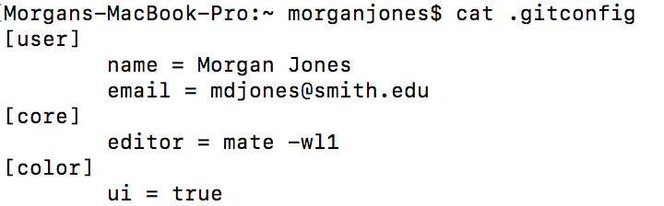

Command to get this listing $ git config --global

|  |  |  |
| --- | --- | --- |
| Config file location | --global use global config file  --system use system config file  --local use repository config file  -f, --file <file> use given config file  --blob <blob-id> read config from given blob object |  |
| Action | --get get value: name [value-regex]  --get-all get all values: key [value-regex]  --get-regexp get values for regexp: name-regex [value-regex]  --get-urlmatch get value specific for the URL: section[.var] URL  --replace-all replace all matching variables: name value [value_regex]  --add add a new variable: name value  --unset remove a variable: name [value-regex]  --unset-all remove all matches: name [value-regex]  --rename-section rename section: old-name new-name  --remove-section remove a section: name  -l, --list list all  -e, --edit open an editor  --get-color find the color configured: slot [default]  --get-colorbool find the color setting: slot [stdout-is-tty] |  |
| Type | --bool value is "true" or "false"  --int value is decimal number  --bool-or-int value is --bool or --int  --path value is a path (file or directory name) |  |
| Other | -z, --null terminate values with NUL byte  --name-only show variable names only  --includes respect include directives on lookup  --show-origin show origin of config (file, standard input, blob, command line) |  |

## Auto-completion Set Up

You don’t need this, but could be helpful in the future. This needs to be constructed for Mac and Unix, but Windows should already have auto-completion included.

[1] Download from Github

* Change user directory

$ cd ~

* Use curl tool (go to URL)

$ curl -0L <https://github.com/git/git/raw/master/contrib/completion/git-completion.bash>

* Rename file

$ mv ~/git-completion.bash ~/.git-completion.bash

* Format: mv ~/original_name ~/new_name

* Changing it so there is a “.” in front

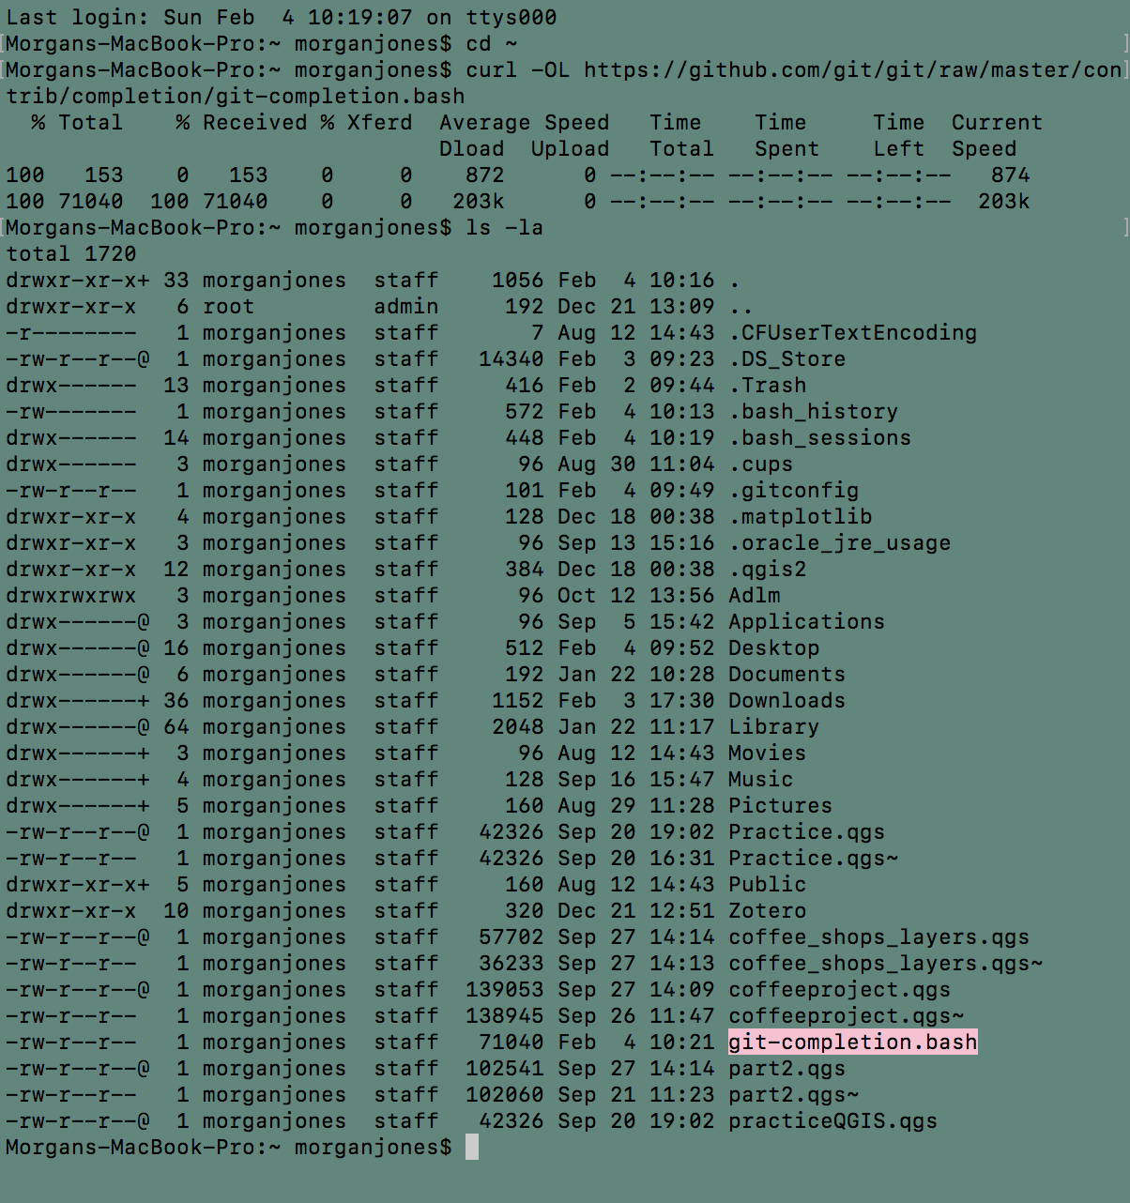

[2] Add/edit to login configuration

~/.bash_profile **or** ~/.bashrc

* Code

$ nano .bash_profile

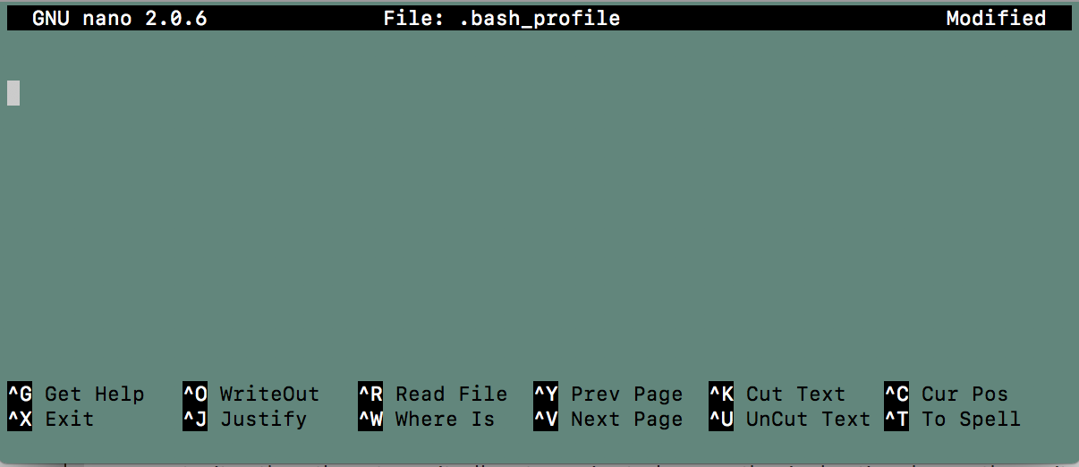

* Put in code

if [ -f ~/.git-completion.bash ]; then

source ~/.git-completion.bash

fi

SO, now when you start writing something, you can press ‘Tab’ and it will auto-complete

## Using Git help

Returns page of commonly used commands.

Command General: $ git help

Command Specific: $ git help _command_

* $ man git-_command_ get you the manual for _command_ too

Spacebar, “f” → to move forward

“b” → to move backwards

“q” → to quit

# **3.0 Git Concepts and Architecture**

## Three-tree Git architecture

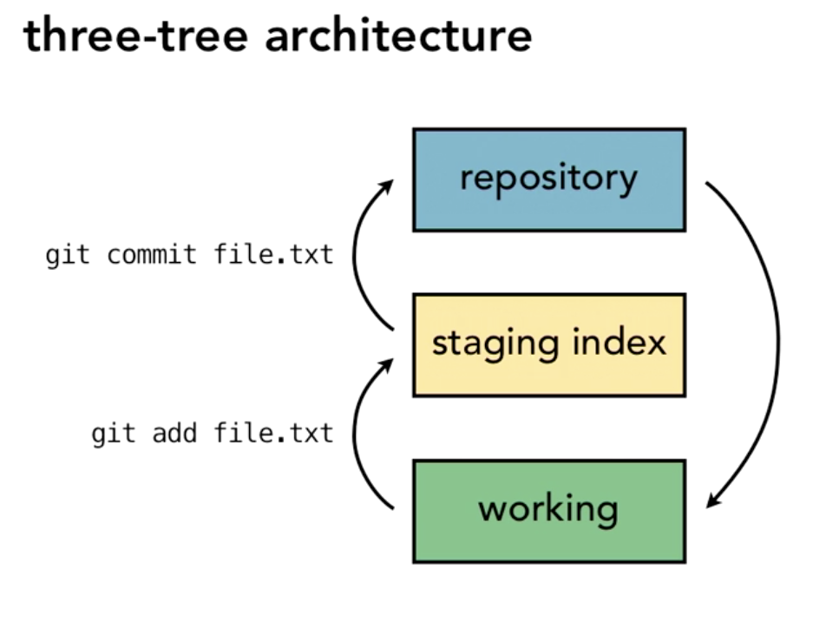

1. Repository Tree (storage)
   1. Permanent files (all being tracked) with commit files attached
   2. Working with sets of files
2. Staging Index Tree
   1. (all commits are stored)
   2. Have to move to repository for Git to track it
   3. Commits are versions of files (snap shots)
3. Working Tree
   1. Can commit working copies to repository

* working directorying changes everything, what happens in the staging and the repository are just for git to use

## Understanding hash values (SHA-1)

Unique feature: “checksum”

Checksum aka: SHA, S-H-A value, commit ID

A checksum is generated for each change set

* Convert data into simple numbers
* Same data = same checksum

40-character hexadecimal string (0-9, a-f)

How we refer to commits

## The HEAD pointer

HEAD → a reference variable (points to a specific commit on the current branch in repository)

* as we make new commits, the pointer going to change point to a new commit

* connected to repository

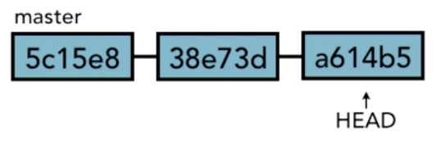

When a new branch is created. HEAD moves freely to and from branches. Moves to currently checkout out branch from the repository.

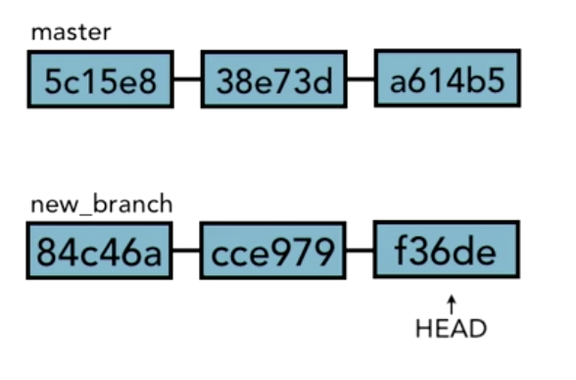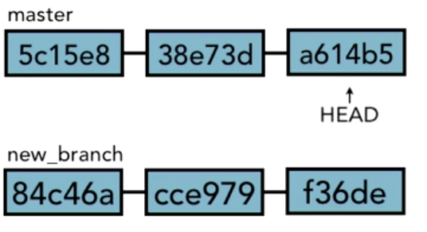

Keeping track of head:

[1] go to project with “cd”

Ex $ cd Desktop/Research/Lynda/test_project/

[2] open the .git file and show what’s inside → can see HEAD

Ex $ cd .git

$ cd ls -la

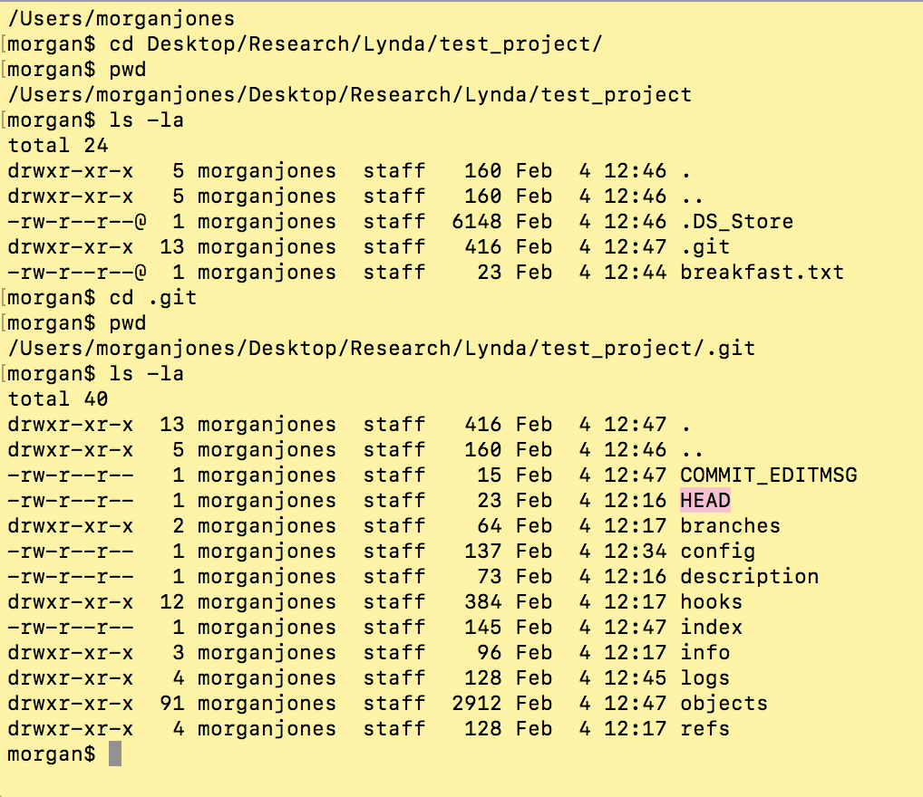

Then we can access the HEAD information



Note: the reference for the HEAD pointer is stored in the .git folder

$ cat .git/HEAD

# **4.0 Getting Started**

## Initializing a repository

Tell Git to start tracking things

Inside user directory $ cd ~

Where project is $ cd Desktop/Research/Lynda/test_project/

Start tacking $ git init

* home base, track files, save changes

## Understanding where Git files are stored

## 

.git is where all the information will be saved (DON’T TOUCH THIS, LET GIT DO ITS THING)

The only thing you might look at is “config” inside .git

## Performing commit

For any work, you can use a text editor (not a word processor)

[1] Make changes

you can do this outside the files

[2] Add changes

$ git add .

[3] Commit changes to the repository with a message

$ git commit -m “Initial commit”

Writing commit messages

Messages: describe the changes that you’re making in commit set. So, when look back at comment, we know what the set did

Best practices

* What was problem/what’s the solution (good label for what is in commit)
* Short single-line summary (< 50 characters)
* Followed by a blank line, and more complete description. (< 72 characters)
* Present tense
* Can add bullet points (asterisks or hyphens)
* Can add “ticket tracking numbers” from bugs or support requests
* Shorthand * everyone should use this
  + [css,js] → working with the CSS and JavaScript
  + bugfix: → something you fixed
  + #40394 - → what sort of support request ticket it goes with
  + Add missing > “where/what”
  + Change user authentication to use blowfish

Viewing the commit log



Look at log history $ git log

Loot at head in repository $ git log HEAD

Look at 5 most recent commits $ git log -5

Look at commits since date $ git log --since=2018-02-11

Look at commits until date $ git log --until=2018-02-11

* Everything before that date

Look at commits by author $ git log --author=”Morgan”

Look at messages $ git log --grep=”bug”

* every commit where “bug” appears will appear

# **5.0 Making Changes to Files**

## Adding files to Git repository

Report difference b/w working directory, the staging index, and repository

$ git status

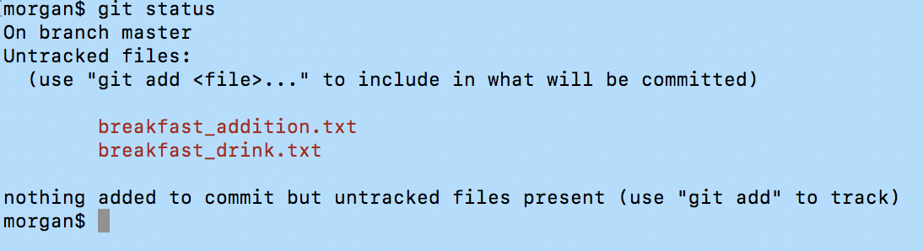

Responds → you have work in your directory (you have new things, and git’s not tracking them) * So, if text edits are made, git can’t tell you want

Now, $ git add breakfast_addition.txt

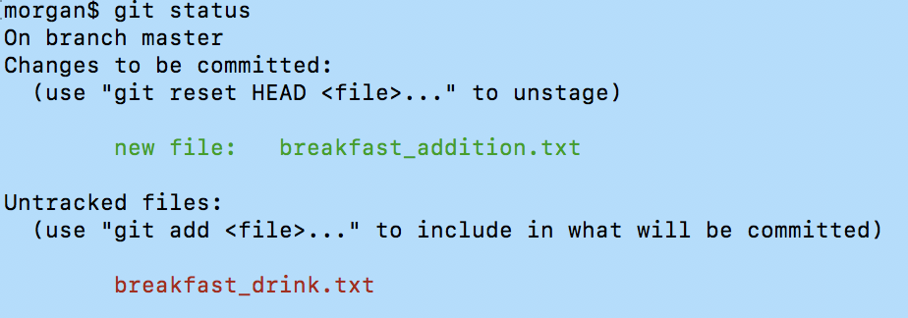

From the response:

“Changes to be committed” this is the staging index (things ready to be committed) * tells us how to unstage things

“Untracked files” are files in working directory

Now, going to commit file to repository

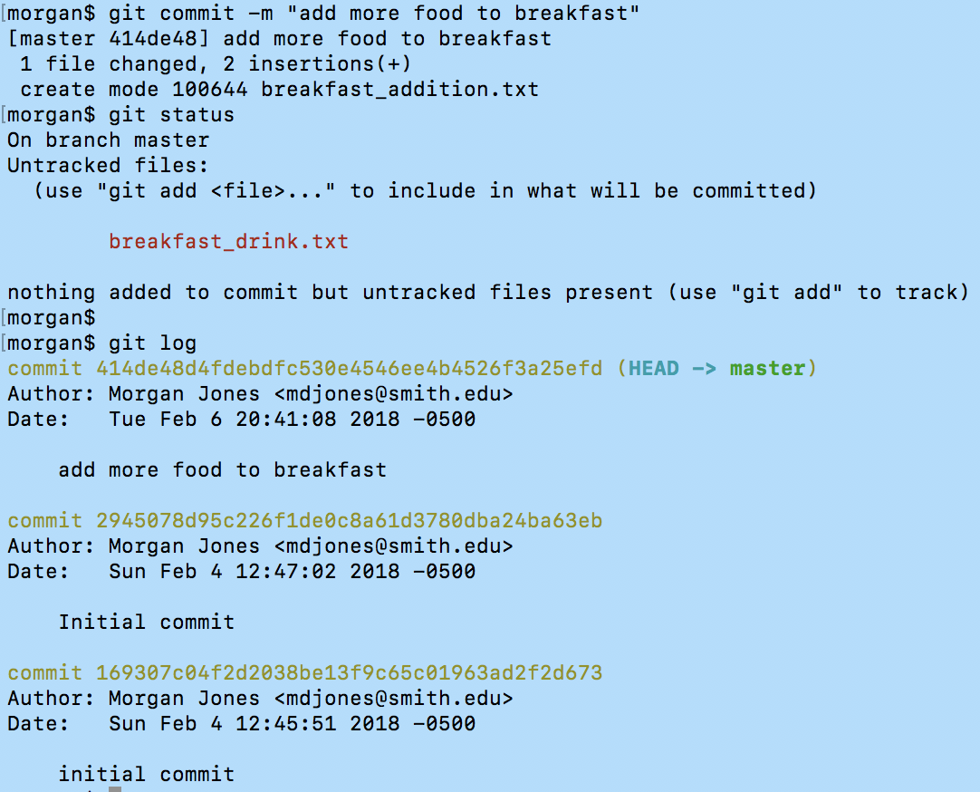

Once file is commited and message is added, the file won’t show up in staging index. The most recent commit added to the repository will show up at the top of the log list.

## Editing files

Working off of last part.

I just made an edit to the “breakfast_addition.txt” file. When we look at the status...

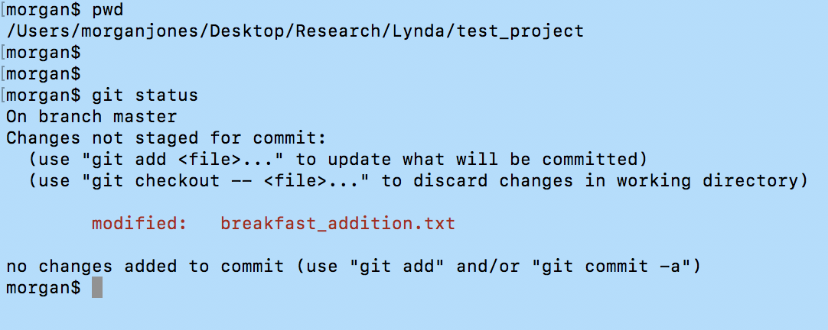

Ahhhhh! Shows that something within the repository changed, so the file appears in the working directory. It gives us options for how to deal with these changes: update commit or discard changes.

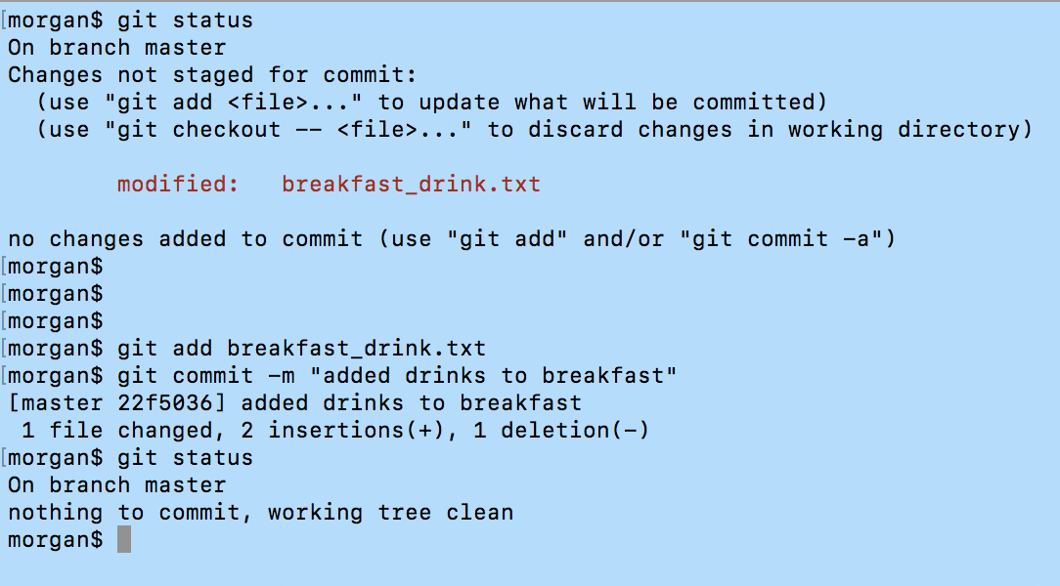

YES! Okay, now understand movement within the three working spaces

* Git status
* Git add
* Git commit

## View changes in working directory

Goal: look at what was changed, then make decision about whether to commit those to repository

Make some edits to a file in the repository

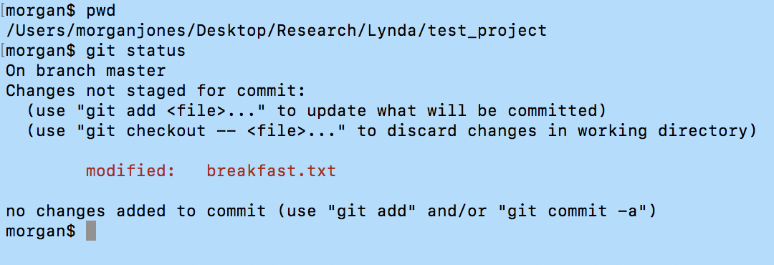

I see that changes were saved -- the file is now in working space. Now, we want to see what changed!! Use **$ git diff** This will compare two files (what’s in repository -- version HEAD is pointing at -- & version in working directory)

* can do by file name too **$ git diff breakfast.txt**

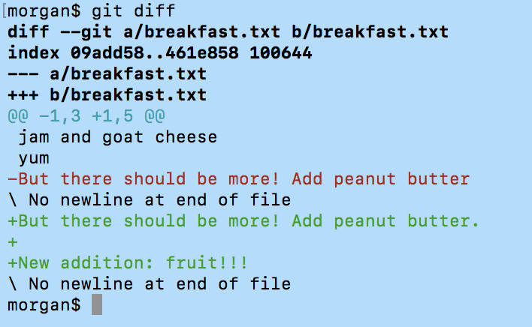

KEY:

“@@ ____ @@” → what lines were old/new versions

“---” → old version

“+++” → new version

Interpretation:

Line change with “-” in front

Added with “+” in front

* ONLY SHOWS what was changed by line

## View changes in staged index

The command is **$ git diff --staged** (earlier version, but works too $ git diff --cached). This will compare two files (what’s in repository -- version HEAD is pointing at -- & version in staged directory)

## Delete files

Added two files to delete later. Show up as untracked files, so doesn’t make a difference. Add to repository (slang “repo”)

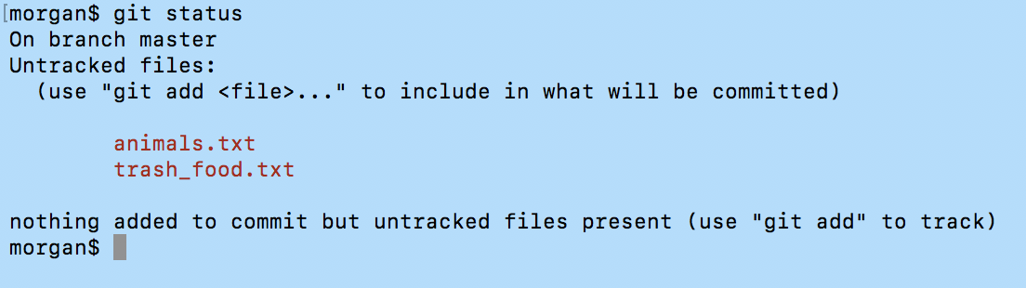

Two ways of deleting files

1. Take file from folder and drag to trash, then remove from repository **$ git rm <file name>**

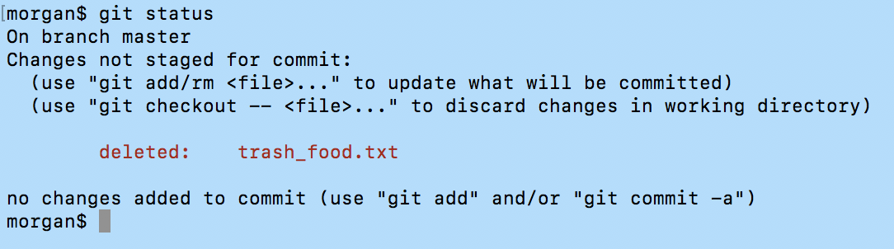

The repository says “Hey, tash_food.txt has been deleted!”. We can use the git add like before because git add is only for adding file or adding changes to a file. SO! Use **$ git rm trash_food.txt** *Note: autocomplete will only use ones in directory (so must spell out).

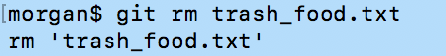

Now, that solidifies the change!

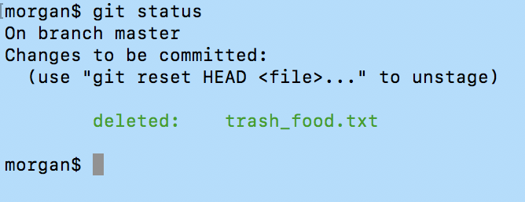

And we have to commit to this “staged” action

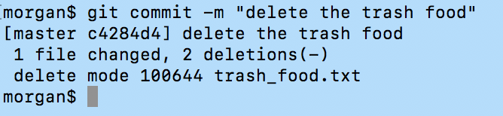

Sweet deal, it’s been removed for good.

* Note: if you wanted to recover this file you could, because you can go into your trash and drag in back into your project folder.

1. Directly delete the file in the command line with $ git rm file_name.txt

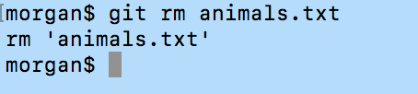

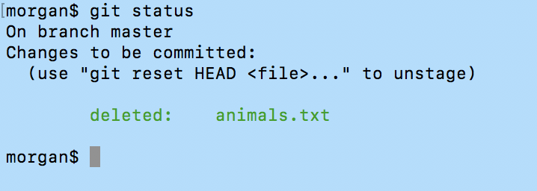

This ready to be be removed.

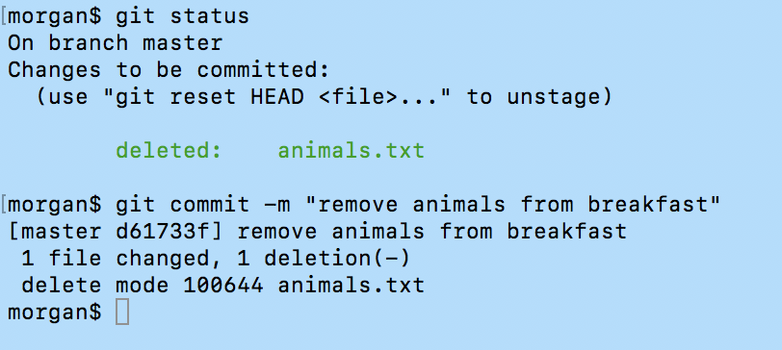

* Note: this will permanently delete it from everywhere. There is no getting this file back.

## Renaming/Moving files

Two ways of moving/renaming files

1. Drag to move files and rename them in folder (in the operating system). Then tell Git about those changes and stage changes.

First, rename file in operating system (directly in the folder) 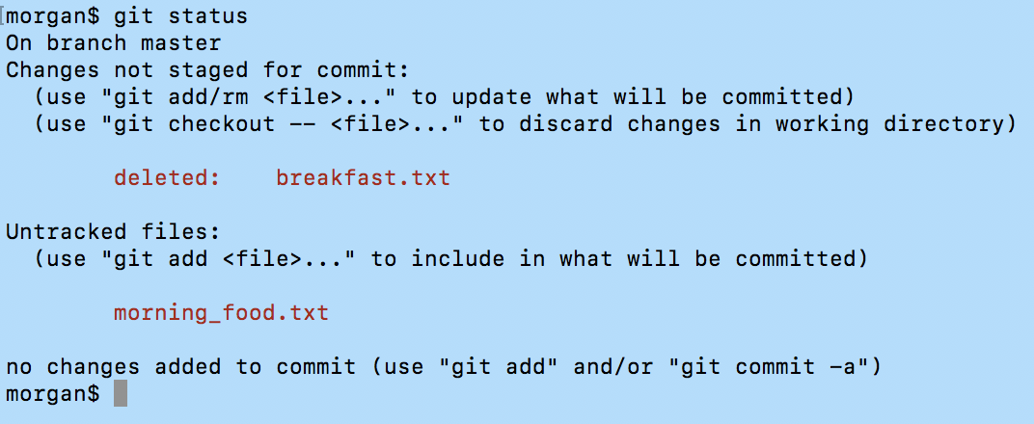

Whoa! It says it’s deleted the file, but it duplicated it and added a different name. So, we complete the transactions.

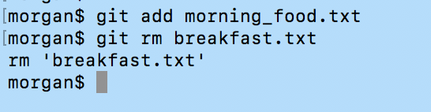

Now Git recognizes that the files were the same and that they were renamed...

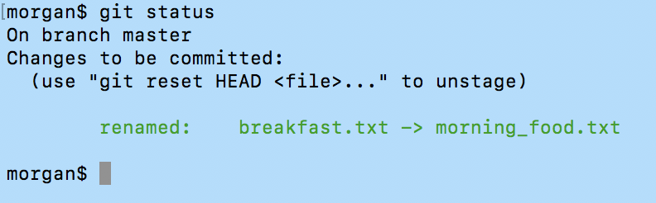

1. Handle change from Git. A rename and a move are the same thing in Git.

Use the command **$ git mv file_name.txt** **newfilename.txt**

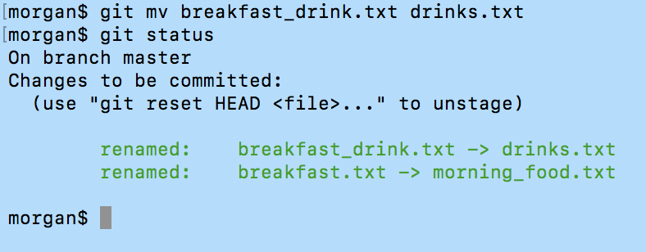

* Note: does it all in one step

Moving files

* same as above

Two ways

1. Drag and deal in operating system
2. All with Git

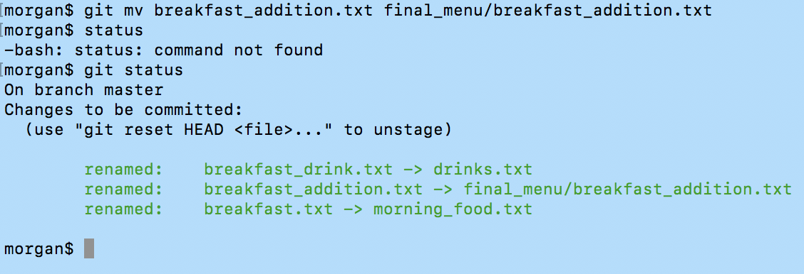 * NOTE: when moved file, could have also renamed it.

===================== Extra stuff ===================================

# **6.0 EXAMPLE: Using Git with a Real Project**

# Initializing Git

Added some new files to git. Git isn’t tracking any parts of the project, so we have to initialize the tracking. You know it’s not tracking a project when **$ git status** and returns “Not a git repository”. It is looking for a .git file, but there is none, so a Git repository must be added with **$ git init**. ** VERY IMPORTANT: the /.git/ file is the file that track project in repository, and it must be in front of all documents. Everything outside that is not in that repository. ** You can have as many git repositories on your computer.

# Editing the support phone number

Back story: what to change number on a created website (file:///Users/morganjones/Desktop/Research/Lynda/explore_california/index.html). I can share the files.

[1] Drag project folder over to TextMate

* Edit > Find > Find in Project… > “find: 4315, replace: 1234”

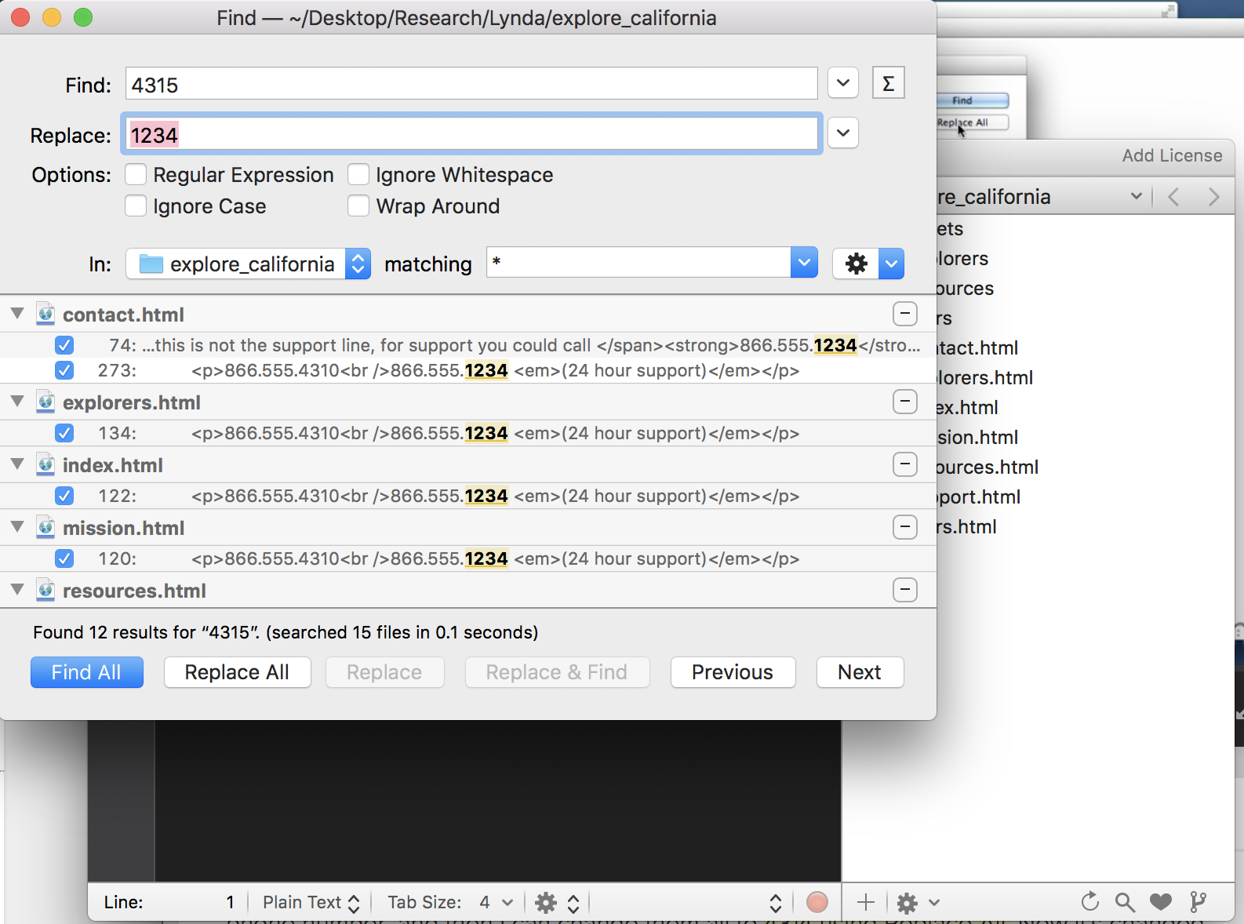

Then save everything “Save All”. Changes are saved in working directory.

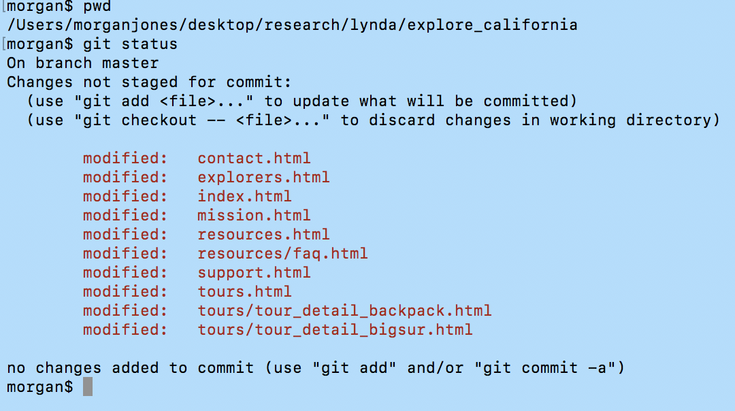

[2] See changes in Git

**$ git diff contact.html**

Displays the changes

“b” backwards

“f” backwards

Toggle long line of text

Minus sign (-) + shift + s + return

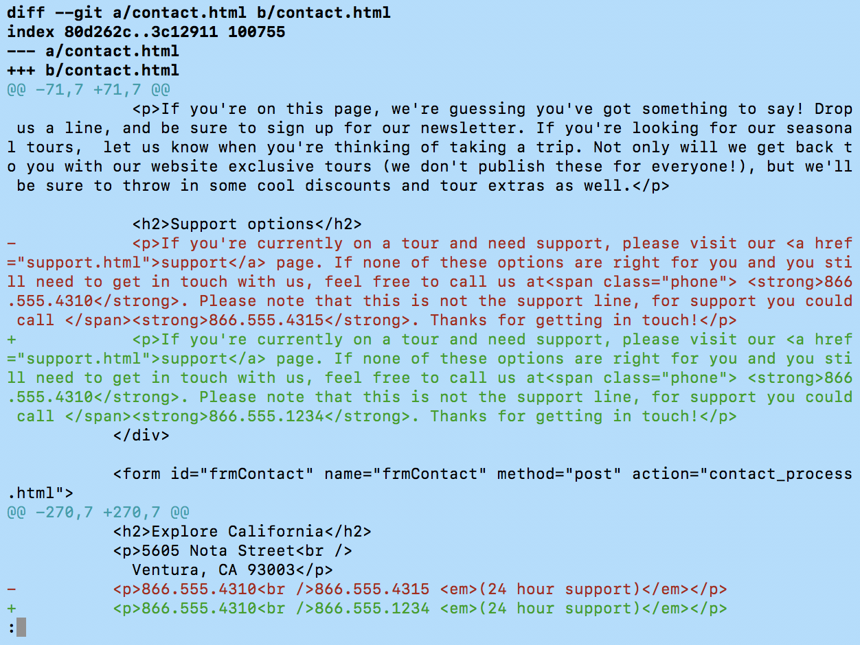vs.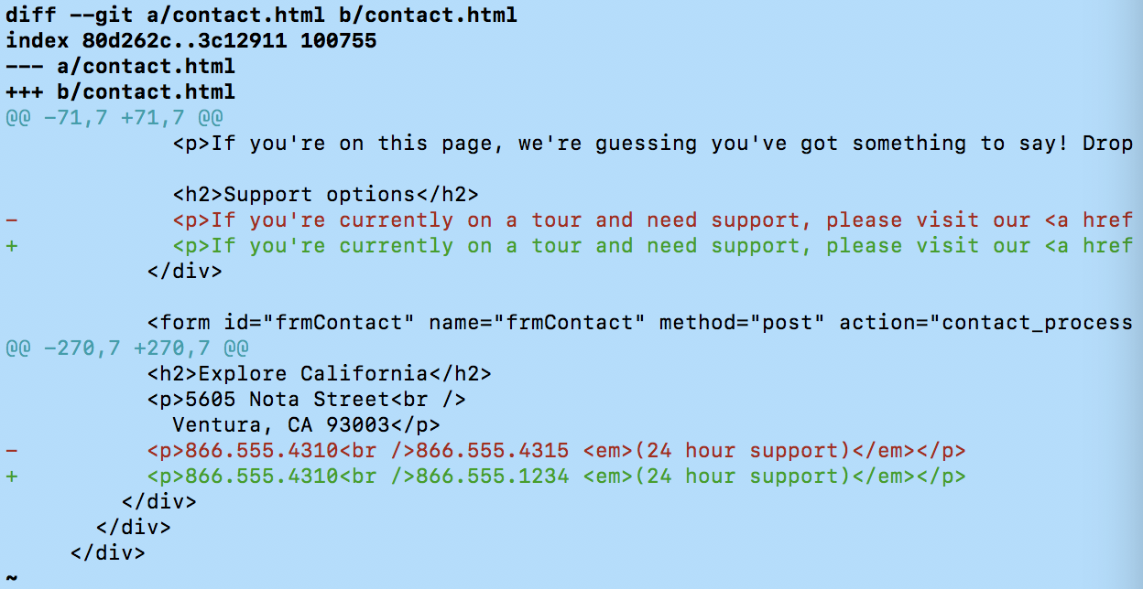

Color the changes

**$ git diff --color-words contact.html**

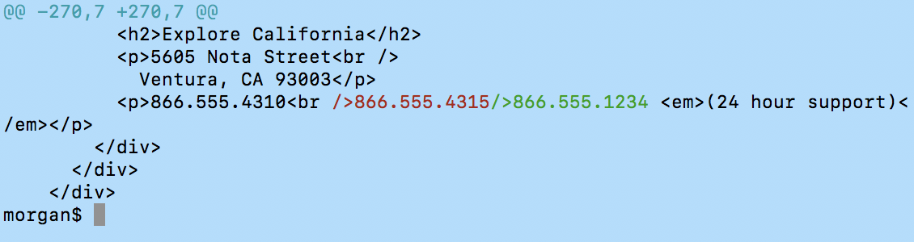

Puts the changes side by side

# Editing the backpack filename and links

* changing linked pages from url to pack

# **7.0 Undoing Changes**

# Undoing working directory changes

Delete text from a text file and save changes, to undo that…

**$ git checkout -- <file_with_saved_deletes_in_it.html>**

* Note: the double dash (--) says stay on the current branch with this file

# Undoing staging index changes

(aka: unstage things that we’ve staged there)

**$git reset HEAD <file_name.html>**

What it says: go to the HEAD pointer (tip of the current branch) which points to last commit and reset to what it was.

# Undoing repository changes (undoing commits)

Quick recap: in the repository, git refers to commit which generate a hash value for all data (the snapshot of all the changes). So, if something is changed, then that hash id changes.

This module has a good video visualization of what changes in the repository looks like.

Everything in the repository references to the one before it as a parent id. So, if something later back is changed all the parent IDs of the ones in front of it must be changed too, which will also change the SHA value of the repository. Git doesn’t let you do this, so it can only change the most recent commit. Everytime an edit is made the SHA changes.

[1] make sure the changes that you wanted that most recent commit to have is done again. For example, this means that you want all changes of a reorganized list to be in the same commit. Make an additional change to the file of the list and put it into the staging index.

[2] Amend the commit

**$ git commit --amend -m “reorganized the list of items”**

[3] Use git log and you can see that there was only one change to the reorganizing of the list.

* NOTE: You can use the same steps if you just want to change the message in the last commit.

# Retrieving old versions

If changes need to be made to older commit (not where the HEAD is pointing), then it is better to make new commits, commits that undo what was done in those older commits. *Important concept: maintains the data integrity of Git.* The log file will also accurately reflect the changes that were made to the files over time.

Ways to make changes

1. Manually make changes to the files
2. Go to git log, copy 10 or so characters to use for reference

**$ git checkout 2908832di2398a -- <fine you’re in>**

**$ git status**

→ puts into staging

**$ git diff --staged**

→ see that it’s the old version

**$ git commit -m “revert changes”**

1. Reverting a commit

If want to undo the changes for a commit completely…

So, anything that was added will be deleted and anything deleted will be added back in. We need to grab part of the reference code from git log.

**$ git revert 2908832di2398a**

1. Undo commits (reset)

Undoes multiple commits (can be very dangerous)

We tell git where to point the HEAD pointer, usually git manages the HEAD pointer for us. It will then rewrite everything in front

**$ git reset**

**-- soft**

will move the HEAD pointer to the specified commit, it’s not going to change the staging index, or the working directory. Just the pointer.

Result: we rewound backwards in our staging index and working directory and repository is set back to an earlier version.

**-- mixed**

This one’s the default. Moves the HEAD pointer to the specified commit and changes the staging index to match the repository. Does not change working directory.

**-- hard**

Will only move the pointer of the repository. Make your staging index and working directory match that as well. So, any of the changes after that commit will be deleted for good.

# Example soft reset

[1] go to git log and copy and past history for safety net

[2] see what HEAD pointer is pointing at now

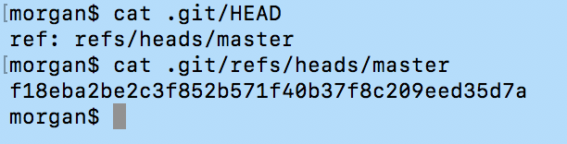

[3] Now, we will use the reset soft with a reference code behind the first commit.

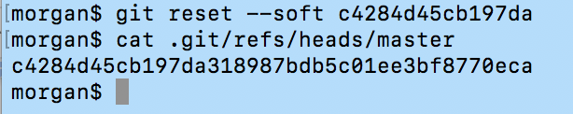

When we do the git log again we see that we will see that the first commit has changed to the code we copied and pasted into the soft reset

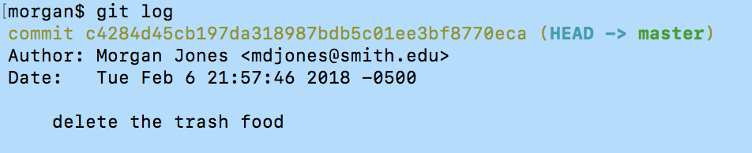

[4] The HEAD has been moved back to that reference code and in a scene be played forward.

[5] Can undo. Copy and paste the original log history first commit. This will change it bad to that.

**$ git reset --soft**

# Example mixed reset

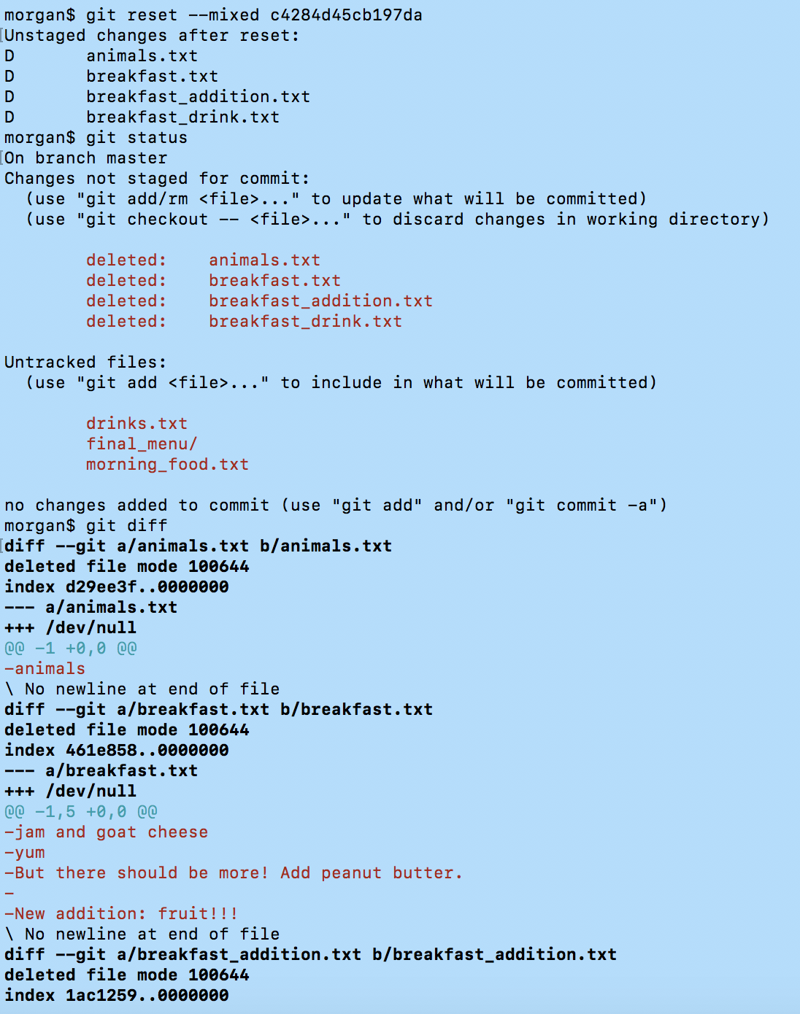

# Example hard reset

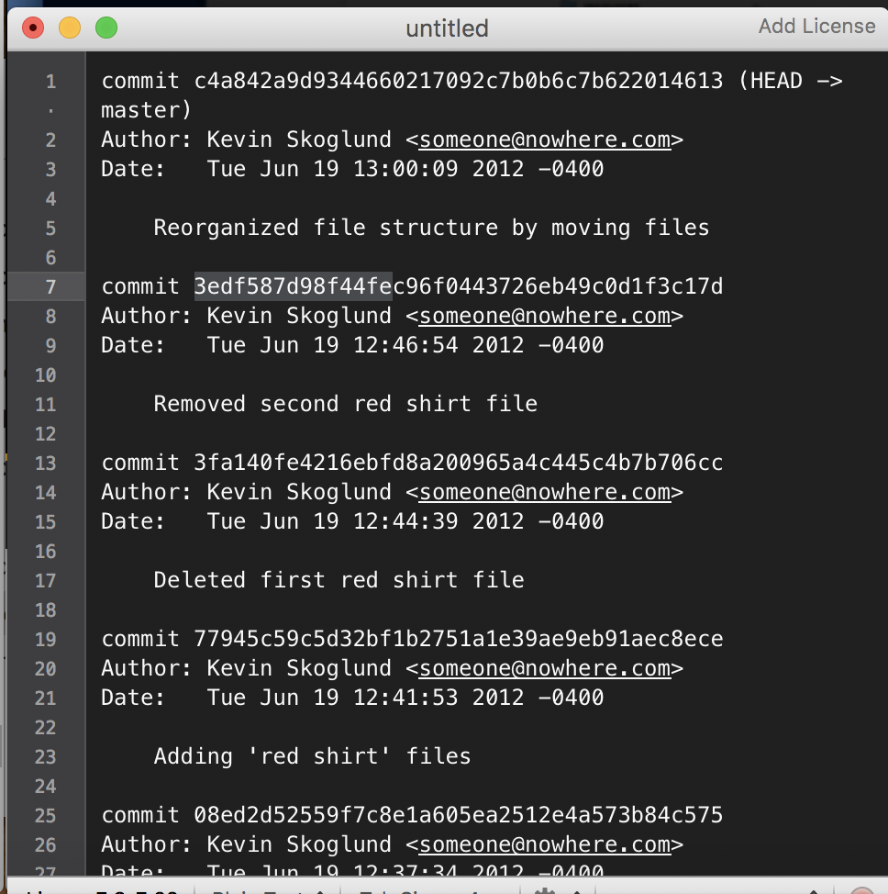

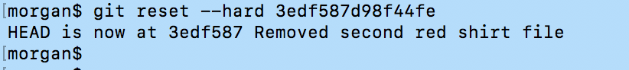

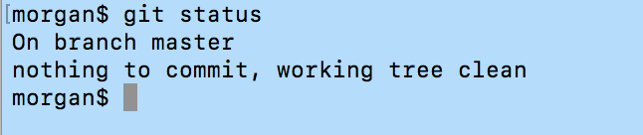

Now, can go back to where it was with original first commit

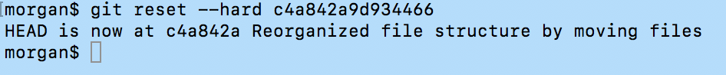

# Removing untracked files

Useful when cleaning up space. Clearing out log files, zipped directories, compiled code, and other things you don’t want in your repository.

Have files in working directory. Will only remove files in working directory. *They will completely deleted.*

**$ git clean**

**-n** will return the files that it will remove (a test run)

**-f** will force the files to removed

# **8.0 Ignoring Files**

## Using .gitignore files

Why would want to ignore: constant changes

[1] add file .gitignore

* Ignore regular expressions * ? [aeiou] [0-9]
* Negate expressions with ! *.php

Means ignore all .php files, but don’t ignore !index.php

* Ignore all files in a directory with trailing slash

assets/videos/

* Add comment lines with #, blank lines are skipped

|  |  |
| --- | --- |
| What to Ignore | Reasons to hide this file |
| Compiled source code | relates to things like the processor that you’re running on your computer |
| Packages and compressed files | (files on their way to somewhere else - it has to uncompressed before it’s usable)   * .zip, .gz, (typically disk image files) |
| Logs and databases | Files that change often. So, everytime do $ git status the changes won’t be shown (they will be saved in the different hidden location) |
| Operating System generated files | Files that don’t relate to project, files that the OS is using to keep track of files |
| User-uploaded assets | Images, PDFs, videos that are user imputed |
|  |  |

More resources

* <https://help.github.com/articles/ignoring-files> (general information)
* <https://github.com/github/gitignore> (more specific commands and uses)

## 

## User-specific Ignore files

Helpful when: there are files you want to ignore in all projects and Git repositories

* Settings will be outside of repository (people who download project won’t get this ignore file) → user specific ignores (not repository ignores)

[1] Make a file for the global ignores

$ nano /Users/morganjones/.gitignore_global

* Add it to the /morganjones/ director next to /gitconfig file

* You can name it anything → I named it .gitignore_global

[2] Configure the file

$ git config --global core.excludesfile ~/.gitignore_global

* after the “~/.” is the path to the file

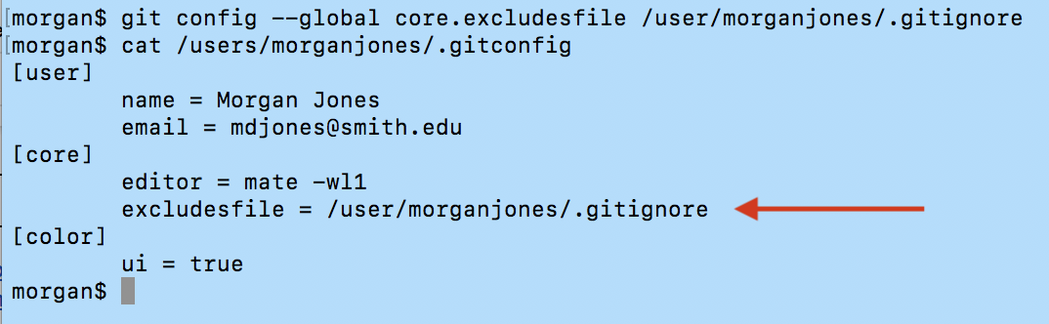

## Ignoring tracked files

Git will NOT ignore a file that was already tracked before a rule was added to the gitignore file, so file must be untracked first

[1] go to file .gitignore_global through nano

$ nano /Users/morganjones/.gitignore_global

[2] Add filename that’s currently committed to the repository to the nano editor

[3] Tell Git to stop tracking file

$ git rm filename.txt

OR

[3] Tell git to stop tracking file, BUT leave file in repository (so someone else can download it)

$ git rm --cached filename.txt

This removes file from staging index

[4] commit changes to repository

## Tracking empty directories

Git designed to be file-tracking system

* Tracks files
* Tracks directories to get to files
* Ignores directories with no files

SO needs some file if you want to track a file

$ touch assets/pdfs/.gitkeep

This will create a file (.gitkeep) in folder pdfs

# **9.0 Navigating Commit Tree**

## Referencing commits

Vocab: Tree-ish → the structure of files in the Git repository, and references part of the tree (reference to a commit)

Ways to reference:

1. Full SHA-1 hash
   1. the 40 character string
2. Shortened SHA-1 hash
   1. At least 4 characters, unambiguous (8-10 characters)
3. HEAD pointer
   1. Points at the commit that’s at the tip of the currently checked out branch
4. Branch reference, tag reference
5. Using any above resources and using their Ancestry

|  |  |
| --- | --- |
| Refer to... | How construct command |
| Parent commit: | HEAD^, acf87504^, master^ |
| Number of generations what to go up → | HEAD~1, HEAD~ |
| Grandparent commit: | HEAD^^, acf87504^^, master^^ |
| (parent of the parent commit) | HEAD~2 |
| Great-grandparent commit: | HEAD^^^, acf87504^^^, master^^^ |
|  | HEAD~3 |

## Exploring tree listings

[1] Get into directory where project is

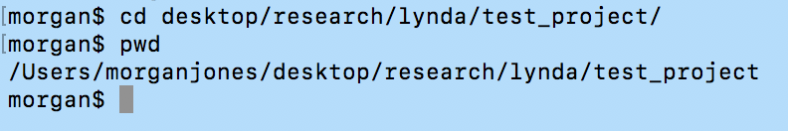

[2] Points to the HEAD and see the files in the repository at that point. So, if you where to “check out” this HEAD out from the repository, theses are the files it would give you

$ git ls-tree HEAD (type of tree-ish)

## 

[2] You can see that Git points to the same thing, that because the master branch is checked out right now, so HEAD points to the top of that.

$ git ls-tree master (type of tree-ish)

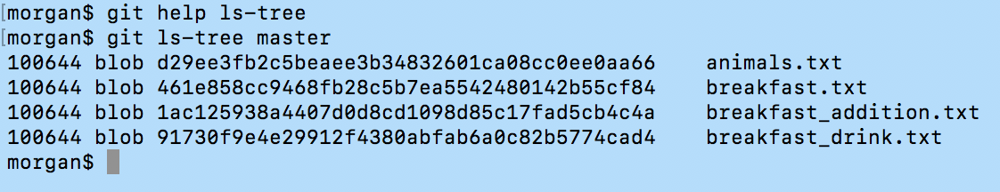

[2] Can so refer to file directory and pass in a file path there

$ git ls-tree master foldername/ This will return the files in that directory.

$ git ls-tree master^ Can go back one commit

Note: The files will appear as “blob” or “tree”

“Blob” → is any kind of file that’s stored there (ex text file, image, etc.)

“Tree” → is a directory. We’re inside a tree b/c had a tree-ish that pointed to a tree then inside that tree are other trees (if not a blob, then a tree)

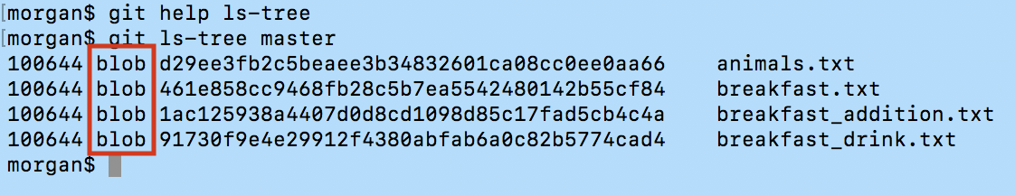

## Viewing Commits (git log)

|  |  |
| --- | --- |
| Command | What it does |
| $ git log --online  $ git log --online -# | One line list of what’s in our log file * Gives part of the SHA if you want to reference it. Can also display curtain number of lines |
| $ git log --format=online  $ git log --format=short  $ git log --format=medium (default)  $ git log --format=full   * Gives commit author   $ git log --format=fuller   * More information   $ git log --format=email  $ git log --format=raw   * The raw information stored in Git | Returns full SHA and onlines |
| $ git log --since=”2012-06-20”  $ git log --after=”2012-06-20”  $ git log --until=”2012-06-20”  $ git log --before=”2012-06-20”  $ git log --since=”2 weeks ago” --until=”3 days ago”  $ git log --since=2.weeks --until=3.days | Refer to logs by date. ‘Since’ displays all commits since date |
| $ git log 2907d12..acf8750 --oneline | Range for time periods (..) |
| $ git log -p | If you’re working on a particular file and what to see what have changed over time in the file. Find details about the commit, this is the *patch* option. Shows the changes. |
| $ git log abc23fd12.. filename.txt | Search range and commits relevant to specific file. The ‘..’ is left blank at the end, so means to the most recent. Returns what changed with that file over those commits |
| $ git log --author=”Morgan”  $ git log --author=”Morgan Jones” | Search by author |
| $ git log --grep=”temp” | Using global regular expression search (GREP). Searches for files names and commit messages that have “_” word |
| $ git log --stat  $ git log --summary  * can do together or separately | Gives idea of changes when and where |
| $ git log --graph | Returns a graph of each one of the commits (helpful when have branches and merging |
| $ git log --online --graph --all --decorate |  |

Can find many more helpful log maneuvers through $ git help log

## Viewing specific commits

|  |  |
| --- | --- |
| Command | What it does |
| $ git show --format=online HEAD |  |
| $ git show 2907d12 | Must reference SHA code |
|  | For tags, shows the tag message and referenced objects |
|  | For trees, shows the names |
|  | For blobs, shows plain contents |
|  | For commits, shows log message and textual diff |

## Can look at blobs, trees, tags, commits

## 

## Comparing commits

This is not just showing the snapshot changes of the commits, it is comparing the directory that that commit references (a comparison of all those files at that point in time)

$ git diff

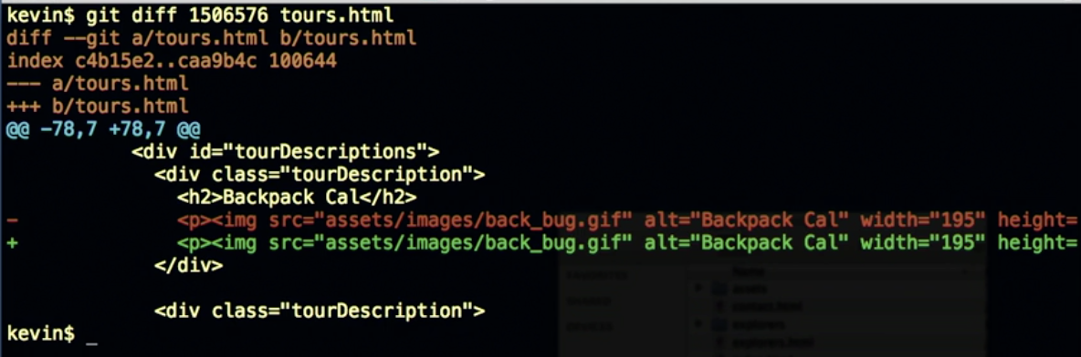

$ git diff cf78bd8..cdae0ed

$ git diff cf78bd8..HEAD

$ git diff cf78bd8..HEAD^^

All these compare the commits over this period of time (between these two commits)

$ git log -- stat --summary cf78bd8..HEAD

Sows summary of what’s changed, a list of the files with an idea of the changes

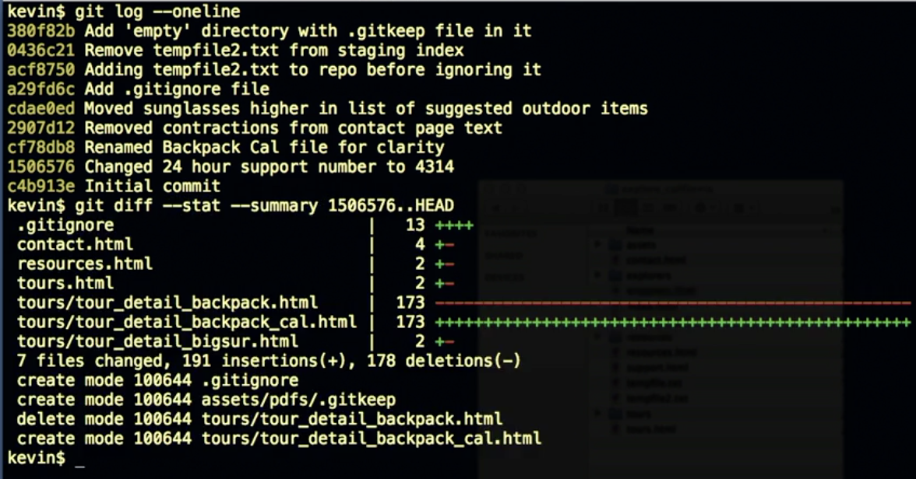

$ git log -ignore-space-change cf78bd8..HEAD == $ git log -b cf78bd8..HEAD

Will ignore whether or not someone changed one space to two spaces, four spaces to five spaces

$ git log -ignore-all-space cf78bd8..HEAD == $ git log -w cf78bd8..HEAD

Will ignore all spaces

# **10.0 Branching**

## Branching overview

Why good idea: don’t take up much processing power or storage space, easy to create, easy to delete, easy to work with, and try new ideas

Ex: have an idea that you what to try out. Not sure if it’s going to work. INSTEAD of making many commits to *master branch* and trying to undo them if it doesn’t work out, can create a branch. Can delete after wards or add to master branch through *merging*.

Ex: in group projects, can work on feature through a branch, while others are still working on the master branch (can submit later).

Notes:

* Branches are cheap
* Try new ideas
* Isolate features or sections of work
* One working directory

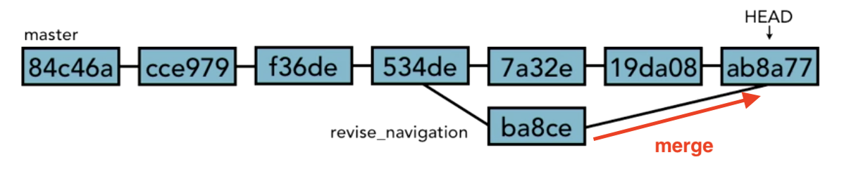Viewing and creating branches

|  |  |
| --- | --- |
| Command | What it does |
| $ git branch | Look at all branches in our local repository |

Viewing branches

When do $ git branch... We can see that there is only one (the master branch). This is the default branch. The * refers to the current branch you are on (or the checked out branch).

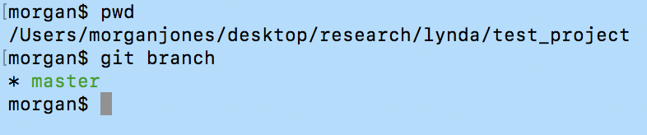

Go to reference folder for HEAD using: $ cat .git/HEAD. It will return the reference to one of the branches (because HEAD always points to the tip of a branch.

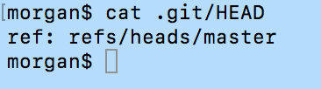

In this folder, you can see what the actual tip is using $ ls -la .git/refs/heads. Will show a directory listing of all the branches that are listed there. When we add new branches this is where they show up

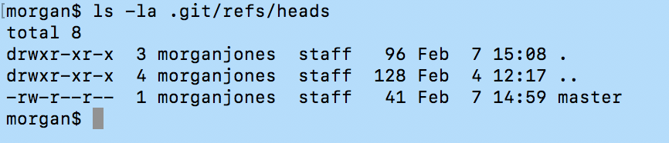

Reference the SHA code using $ cat .git/refs/heads/master. The master/ folder is the file every things branches off from.

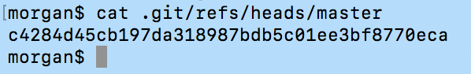

Create a new branch

Where new_feature is the name of the new branch. We can see that a new branch has been created with $ git branch, but the master branch is still the one checked out.

$ git branch new_feature

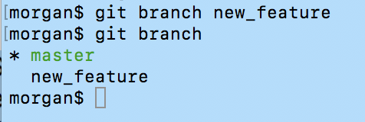

Just to see what happens to the git folder. $ ls -la .git/refs/heads. Can see a new one created.

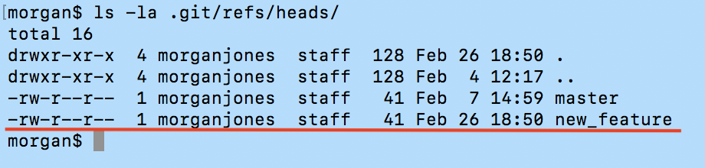

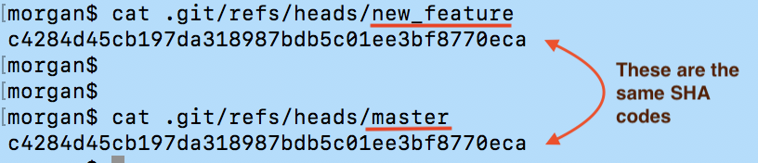

They have the same SHA codes because nothing has changed in the newly created branch yet.

## Switching branches

$ git checkout new_feature (so the name of the newly created branch from the master string).

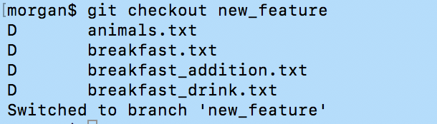

We can confirm that the HEAD has switch to working on the new branch “new_feature” by $ git cat .git/HEAD



Added a file to the desktop folder.

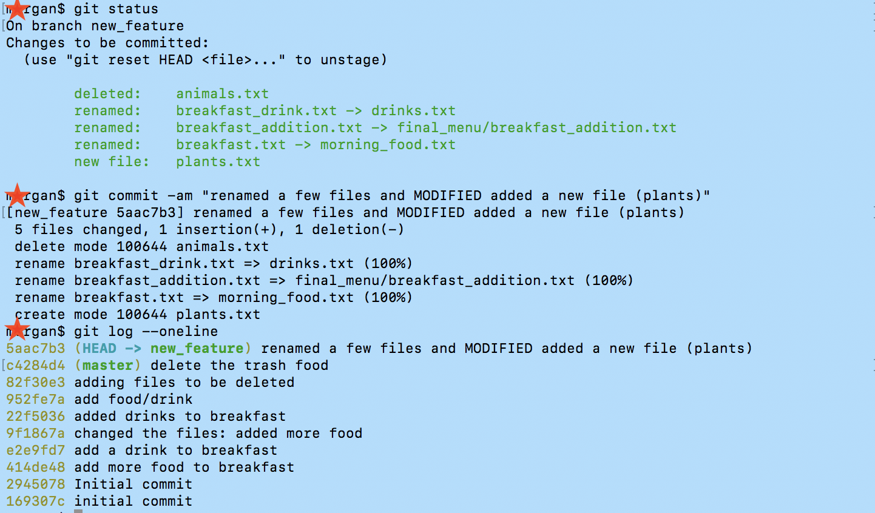

Checkout the master string again to see how it was originally.

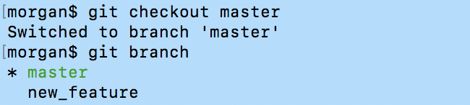

Now that we are switch back to master string, can see that it doesn’t have any additional commits.

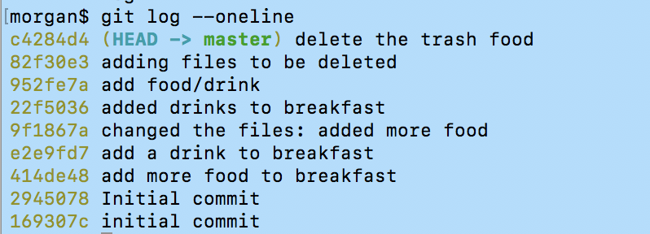

## Creating and switching branches at the same time!

|  |  |
| --- | --- |
| Command | What it does |
| $ git checkout - b new_file_name | Checks out a branch. The -b means create and switch at the same time (“check this out as a new branch”) |

Note: the working directory must be clean when doing checkout. If not, then Git won’t let you make the checkout

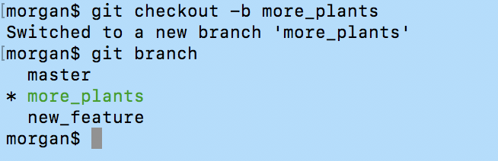

Can use $ git log --oneline and see that more_plants is a branch that was created off of new_features, because it includes all the features of new_features.

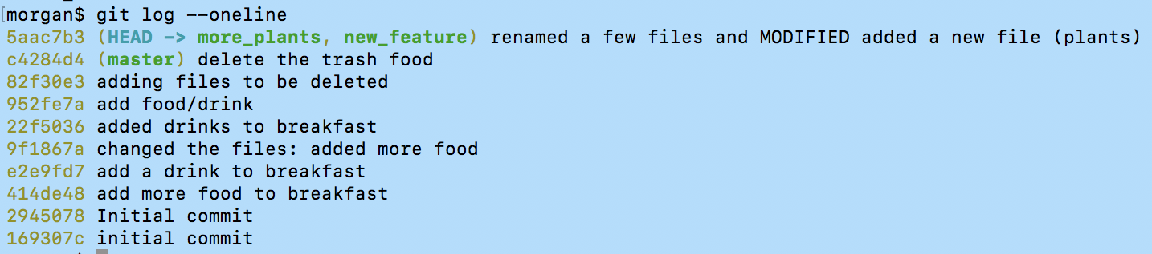

Now make changes to the file “plants.txt” and add it to the “more_plants” branch of the project.

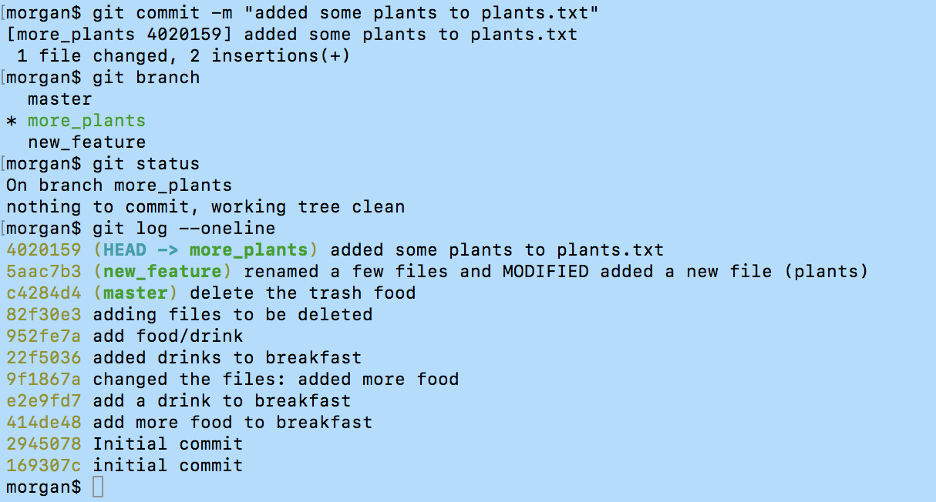

## Switching branches with uncommitted changes

This is the case when the working directory is NOT clean (there are still changes in the directory, but you don’t want to commit them yet).

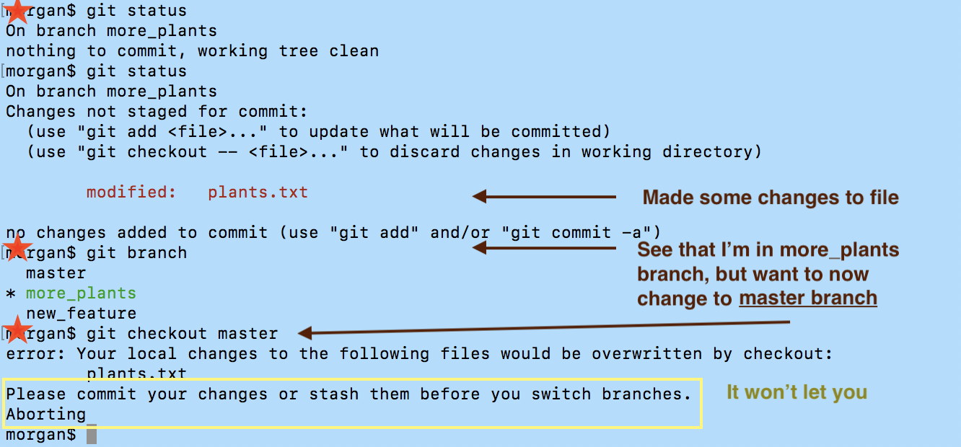

Options

1. Scrap the other changes by checking out the file again. $ git checkout master
2. Commit the changes to the current branch
3. We can *stash* the changes (put the changes in a little pocket for later)
   1. You can’t lose data if you want to make the switch

## Comparing branches

|  |  |
| --- | --- |
| Command | What it does |
| $ git diff file_one..file_two | Compares file_one to files_two |
| $ git diff --color-words file_one..file_two | Shows all changes on one line |
| $ git diff file_one..file_two**^** | Compare file_one to the previous commit of file_two |
| $ git branch --merged | We can find out whether one branch completely contains another branch or not (whether or not everything in it has been merged into the current branch). |

## Renaming branches

Example: rename new_feature

$ git branch -m add_plant_files OR $ git branch --move add_plant_files

## Deleting branches

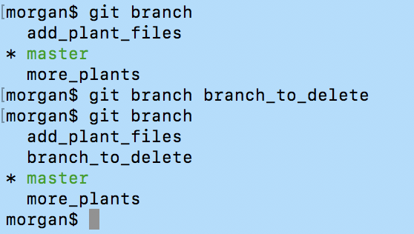

You can see that we stayed in the master branch even when we created branch_to_delete

Now, want to delete. $ git branch -d branch-to-delete

Can also use $ git branch --delete



NOTE: you can NOT be on the branch you are trying to delete. That’s why it’s safe to always be on your master branch when you delete a branch.

What happens when you did a delete by accident!?

* Git has a check where if you have changes in a branch that’s not in the branch that you’re on now, then it will ask you if you really want to delete it

## Configuring the command prompt to show the branches

This is something extra (formatting wise)

Changes the “morgan$ “ ⇒ “morgan(current branch)$ “

For Macs and Linux:

Note the $ is a command substitution

https://github.com/git/git/raw/master/contrib/completion/git-completion.bash

# **11.0 Merging Branches**

## Merging code

Case: When your branched idea works and you want to merge it back into the master string

[1] $ git checkout master (on the branch you want to merge something to)

[2] $ git merge file_want_to_merge

To check

$ git diff master..file_want_to_merge It would return no changes

$ git branch --merged Would return: file_want_to_merge merged to master

NOTE: you ALWAYS want to merge with a clean working directory

## Fast forward merge vs. true merge

Fast forward merge: when you make a branch from the master and don’t edit anything in the master string. So, the branched file can simply just go on top of the master file when you want to merge it back in. The same SHA code will appear at the HEAD on the branched file and the newly merged master file.

|  |  |
| --- | --- |
| Command | What it does |
| $ git merge --no-ff branch | Doesn’t do a fast-forward. Makes a new commit with the commit message anyway.  This will document the merge |
| $ git merge --ff-only branch | Do the merge only if you can do a fast-forward merge. If you can’t then don’t do it. |

True merge: git will figure it out (exceptions below)

* same process as above

## Merging conflicts

MAIN PROBLEM: When you have a different version of the same line. It will mark the conflict and user will fix the problem.

## 

Resolving merge conflicts

1. Abort merge

$ git merge --abort

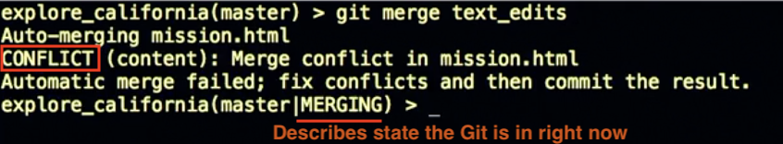

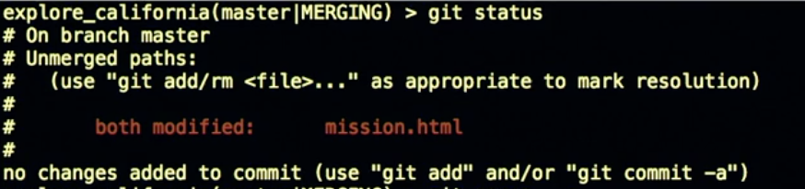

1. Resolve the conflicts manually
   1. Resolve by hand, add and commit results

[1] Open text editor, where trouble appears

Will appear in text editor as

<<<<<< at the beginning of trouble areas, ===== between the two versions, and >>>>> at the end of sections.

[2] $ git add

[3] $ git commit (don’t need a commit, b/c there is a default)

1. Use a merge tool

Can look up, but be comfortable with manually changing it first.

## Exploring strategies to reduce merge conflicts

Tips

* Keep lines short
* Keep commits small and focused
* Beware of stray edits to whitespace
  + Spaces, tabs, line returns
* Merge often
* Track changes to master
  + As changes continue to happen in master, keep bringing those changes into your banch so that your branch stays mostly in sync with master.

Example below: create a new branch from new point in master and merge the old branch to the new branch.

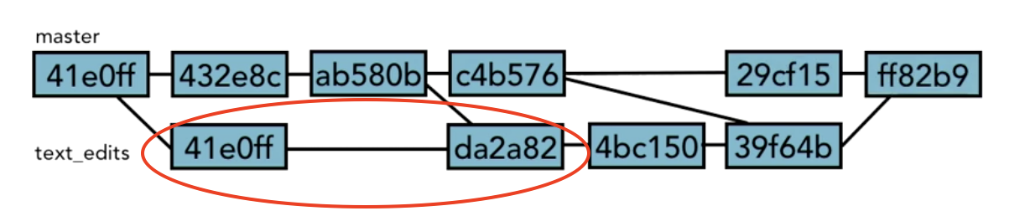

# **12.0 Stashing Changes**

## Saving changes in the stash

Stash is where we store changes temporarily without having to commit them to the repository

* Don’t have SHA

$ git stash save “changes that I don’t want to make now”

This will save it in the working directory and in the branch that you are in

## Viewing stashed changes

|  |  |
| --- | --- |
| Command | What it does |
| $ git stash list | to locate stashed files  The “ stash@{0} “ refers to this specific stash. The “on shorten_title” is the original branch that it was saved too.  * Can pull from stash in any branch that you are in  * {2} is the 3rd stashed file |
| $ git stash show stash@{0} | Will show that information of the stash |

## Retrieving stashed changes

|  |  |
| --- | --- |
| Command | What it does |
| $ git stash apply | This will apply the stashed file and keep it stashed too |
| $ git stash pop | This will apply the stashed file and remove it from the stash file |

## Deleting stashed changes

|  |  |
| --- | --- |
| Command | What it does |
| $ git stash drop stash@{0} | Deletes files from the stash, without applying them anywhere. |
| $ git stash clear | Delete all from stash, all at once. |

# **13.0 Remotes**

# Using local and remote repositories

Remote Repositories (aka remotes in git) allow you to collaborate with others. There’s a remote server where collaborators put their changes. People can then see them and download them to their repositories. Then they can make changes of their own, upload them to the server and then I can download them to my repository. The remote repository works just like Git on our laptop computers. There is an agreement that this is the shared repository that collaborators will sink up all changes.

A collaborator will *push* their changes to the remote, so it can be shared. This will create a origin/master next to the master branch in our local repositories. To download other collaborator’s changes we *fetch* the files. This will commit it to my origin/master, which I will then sync to my master branch through a *merge.* Side note: there is not actually 2 branches, the origin/master will use a pointer to indicate where shared information stopped/started.

|  |  |
| --- | --- |
|  |  |
|  |  |

The general process that you will follow:

[1] Do commits locally

[2] fetch the latest from the remote server

[3] get your origin branch in sync,

[4] merge any of the new work you did into what just came down from the server

[5] push the results back up to the remote server

* When someone else is working on something at the same time as you… The origin/master will sync up and then we will have to merge them and sync them back up to the remote server.

# Setting up a GitHub account

<http://github.com> And FREE

[1] create an account

[2] create new remote repository

Remository name (should match project name)

Add description

“Initialize this repository with a README”

This creates your first commit to solidify project

Add gitignore file, if want

Submit

[3] Quick set up  
* Get the HTTP

1. Create a new repository
2. Push an existing repository
3. Import code from another repository

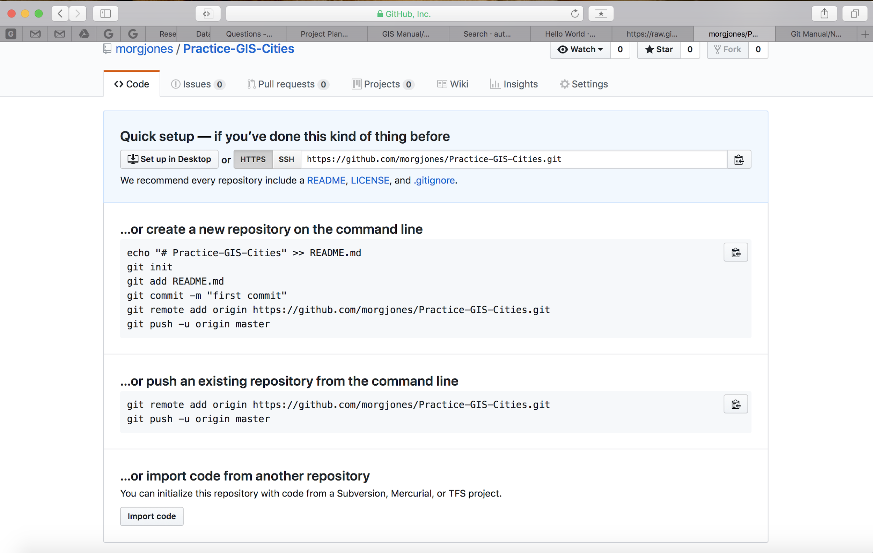

# Adding a remote repository

Need to tell the local repository how to connect to the remote.

[1] get into project fold on the command line

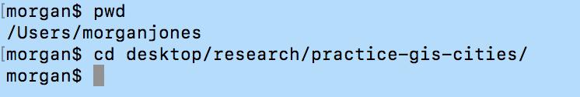

[2] Get a list of all the remotes that Git knows about

$ git remote

* Nothing will appear right now, because nothing is connected

[3] connect the remote to the local repository

$ git remote add <alias> <url>

So, we will get the “alias” for what we want to name the remote and “url” for where to find it from the Github remote repository we just created.

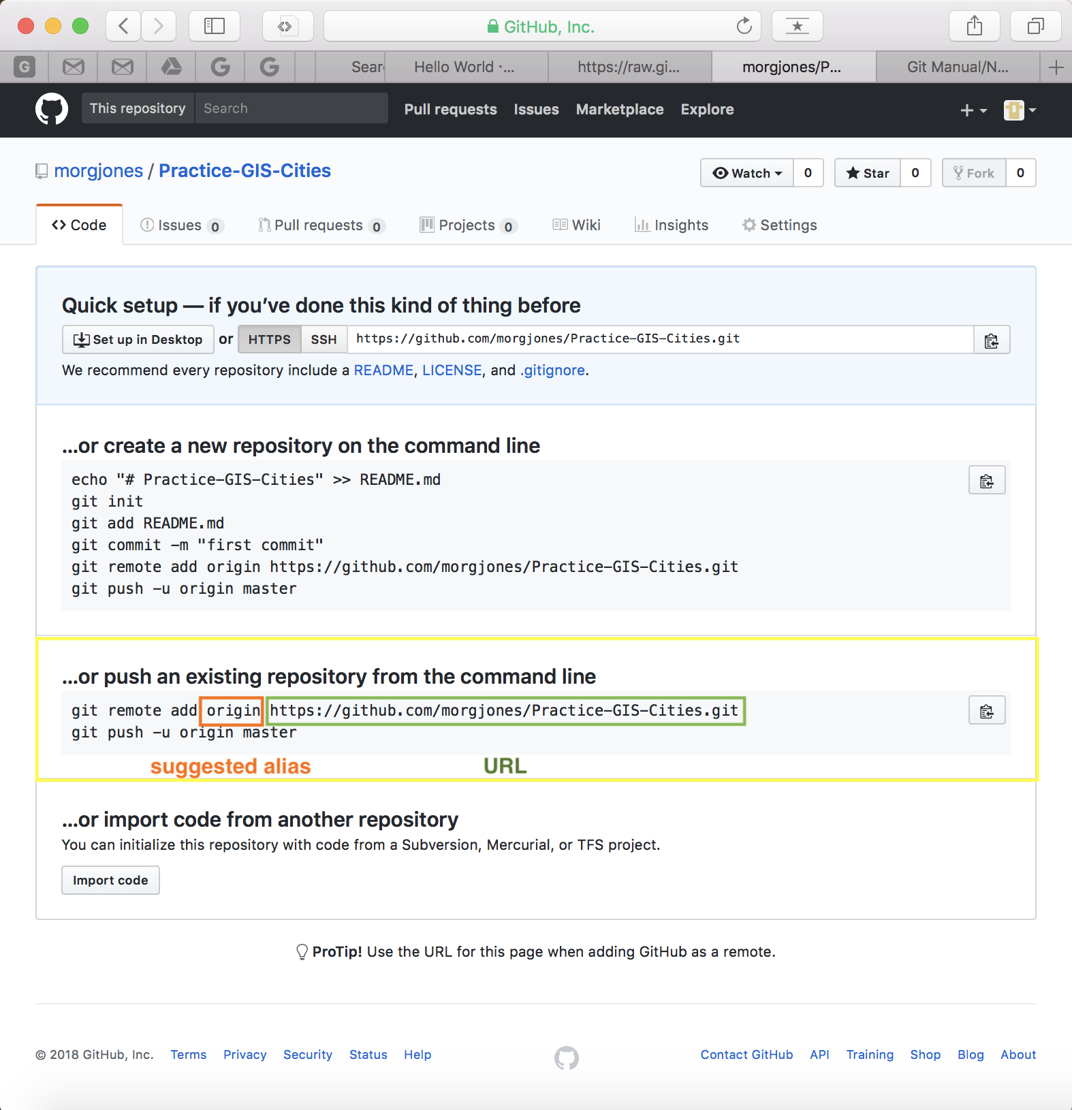

$ git remote add origin https://github.com/morgjones/Practice-GIS-Cities.git

Side note: you can have many different remotes connected to project

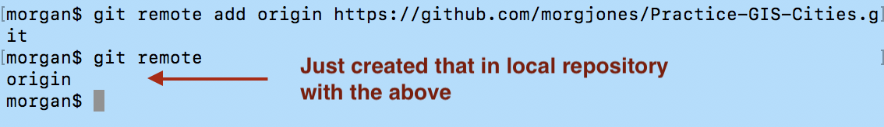

Command Recap:

|  |  |
| --- | --- |
| Command | What it does |
| $ git remote | Shows the remote repositories the local repository can find |
| $ git remote add <alias> <url> | This allows the local repository to locate the remote repository |
| $ git remote -v | give more details about remote located by the local repository. This will return the links that fetch (take files from the remote) and the push (syncs the local repository changes to the remote). Stores these in the .gi/config file |
| $ cat .git/config | Find the fetch/push URLs |
| $ git remote rm <alias> | Remove a remote |

# Creating a remote branch

*Push* our code to the remote branch

[1] $ git push -u origin master

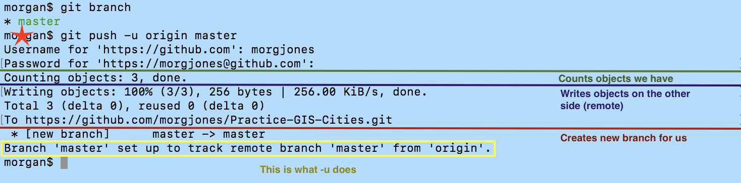

[2] Now can see changes submitted to Github

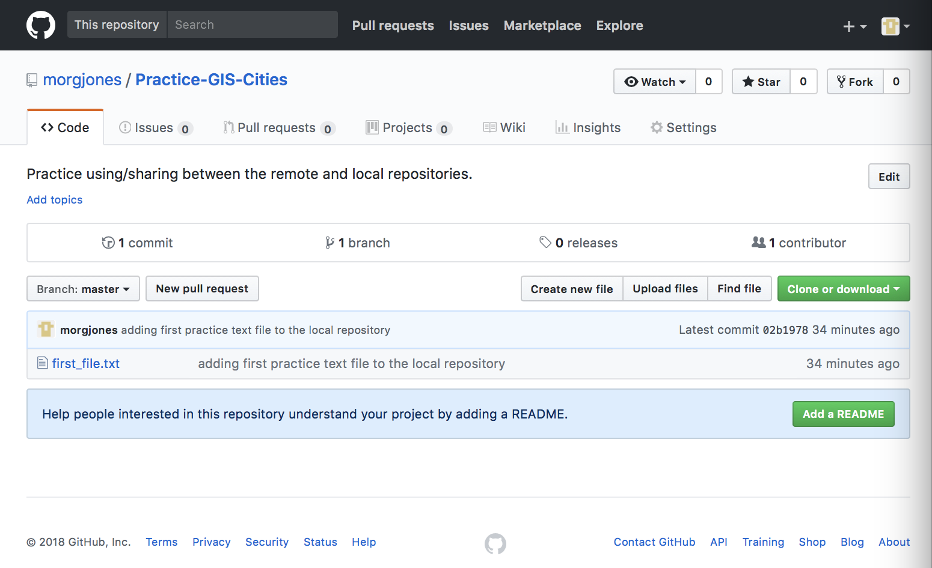

Note: you can view the contents of the files, the commits, the viewing a chart of different commits over time, looking at graphs

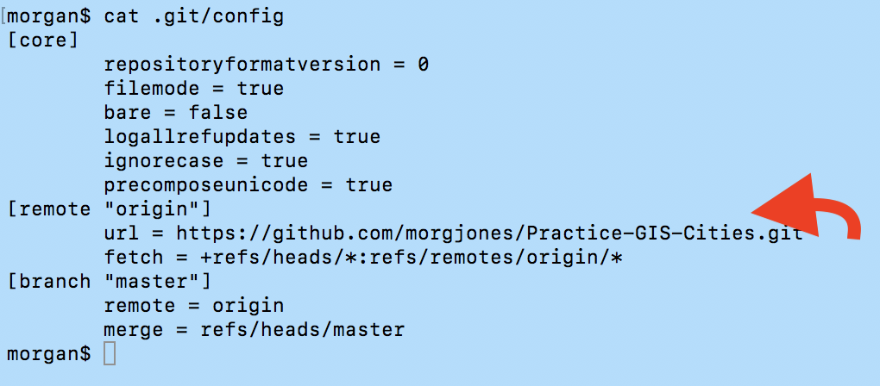

We can also see that the remote is equal to the origin, which is defined and pointed out by the arrow.

We will now look at the location of this interaction.

$ ls -la .git/refs

$ cat .git/refs/remotes/origin

Command Recap:

|  |  |
| --- | --- |
| Command | What it does |
| $ git push - u <alias> branch | This will push a branch up into Github  * The first time it will ask for your user/pass |
| $ git branch -r | Shows the remote branches |
| $ git branch -a | Will show you both local and remote branches |

# Cloning a remote repository

How you deal with an existing repository that someone else has. So, pulling a remote repository and copying it to the local repository. (assuming we don’t have one to start with)

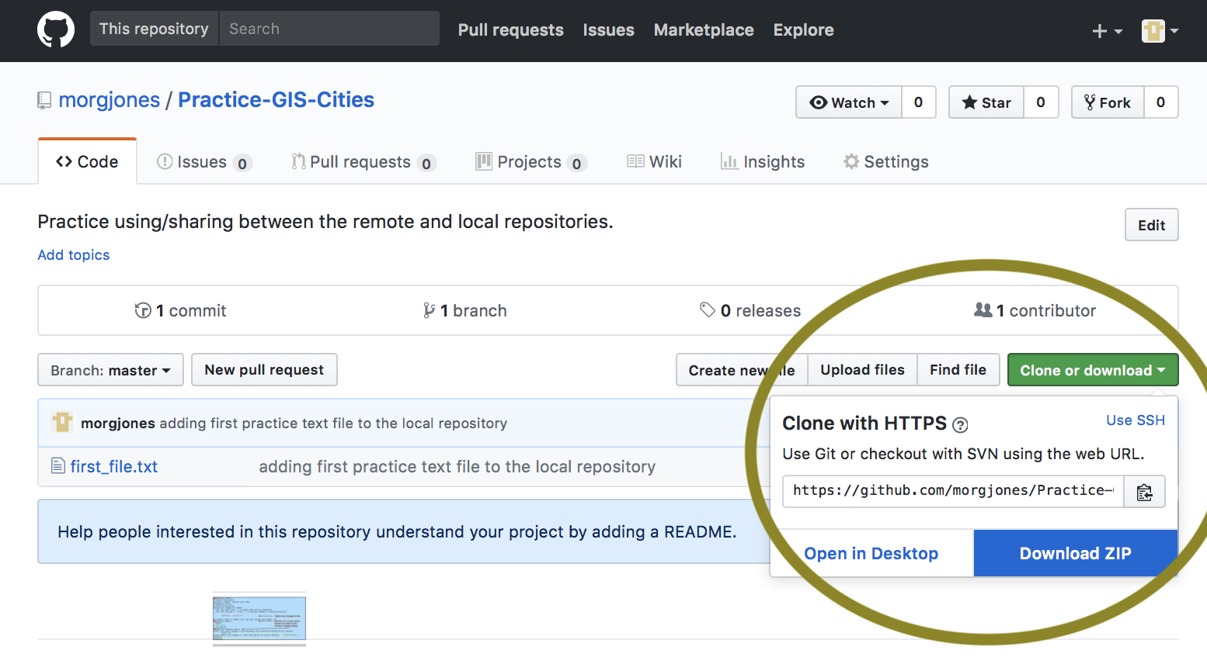

COPY THAT LINK! (https://github.com/morgjones/Practice-GIS-Cities.git) This is the way we refer to the repository.

$ git clone https://github.com/morgjones/Practice-GIS-Cities.git

SO, this will also create a new directory of the name Practice-GIS-Cities. If you want to do it under a different name, you will add a folder name after that.

$ git clone https://github.com/morgjones/Practice-GIS-Cities.git lynda_version

Now it will be created in a folder called “lynda_version”

# Tracking remote branches

Want to keep the master remote and local repository pretty in sync. You can add default tracking to a branch. The -u says this is the branch that we’re going to be working with in the future. If we don’t do git push witht the -u option, it doesn’t track any remote branches.

Ways to start tracking:

1. $ git config branch.<file_name>
2. $ git branch --set-upstream file_name origin/file_name

# Pushing changes to a remote repository

$ git push origin master to push up changes to remote

Can also just do $ git push It will assume where you go (the default)

# Fetching changes from a remote repository

$ git fetch origin but because we only have one remote repository we can use…

$ git fetch

These will bring them down into our local repository, but they aren’t in our master branch yet.This just updates origin/master, not master!

We can see that they were brought down by

$ git branch -r

Guidelines:

* Always fetch before you work
* Fetch before you push
* Fetch often (especially before leaving internet)

# Merging in fetch changes

Learn how to incorporate the synced files from the origin/master into our master all within our local repository.

Example:

The master is two steps behind the synced origin/master.

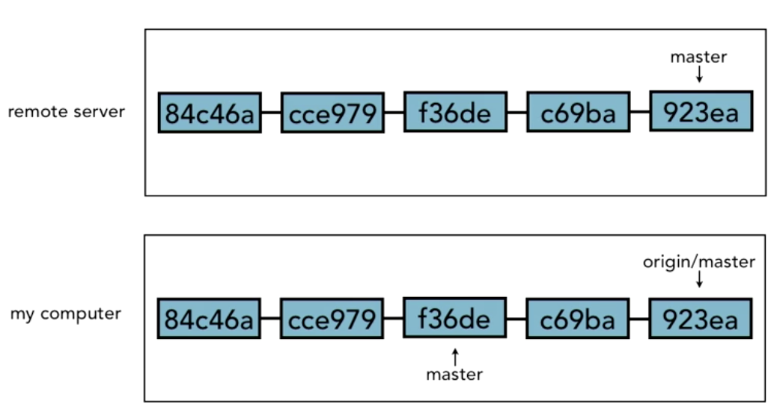

So, we need to merge. We are merging master and origin/master

$ git branch --merged

Command Recap:

|  |  |
| --- | --- |
| Command | What it does |
| $ git pull | This will do $ git fetch and $ git merge at the same time. |

# Checking out remote branches

$ git branch origin/non_tracking origin/non_tracking

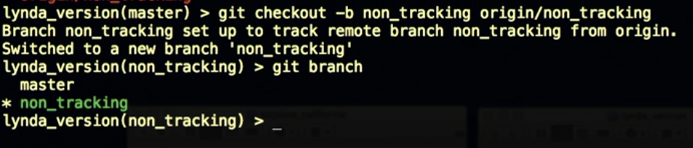

# Pushing to an updated remote branch

Git never tries to do a merge during a push (so, never combines branches while …)

Scenario: Git won’t let you merge “ba8ce” up because more commits have been made.

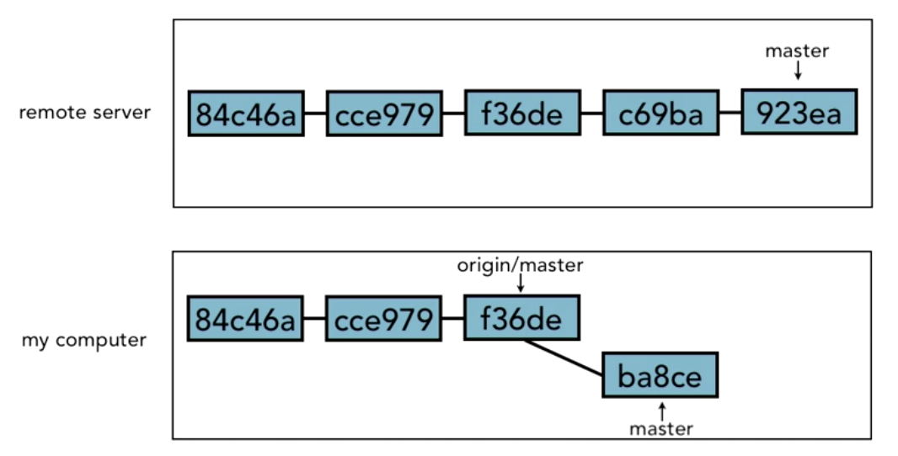

So, We must fetch the new information…

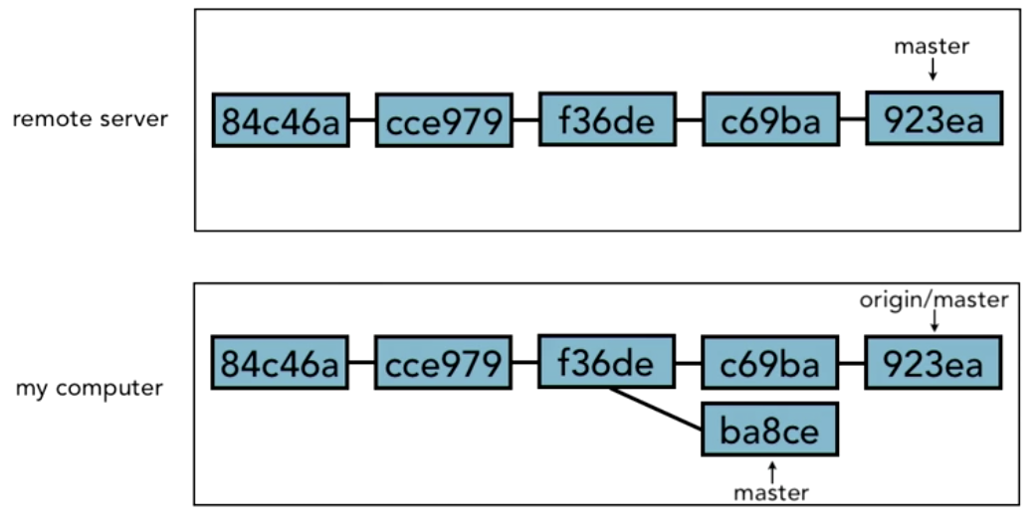

Now we will merge “ba8ce” to the origin master and push it again to the remote server

# Deleting a remote branch enabling collaboration

Two ways

1. $ git push origin :non_tracking (note: non_tracking is a branch in the remote server)
2. $ git push origin --delete non_tracking

# 

# Collaboration

Want other people to collaborate on your project. Add them by searching username in collaborators. They will be sent any email that “they’ve been added to the repository” and also provide them with the HTTP URL, so they can connect it to their local repository.

* The open source way is slightly different (more information on video)

# A collaboration workflow (Review)

Before:

* The remote/local repository is set up
* Must push at least the master branch to remote repositories

[1] Start in your local repository and start on the master branch

$ git checkout master

[2] Always grab what’s from the remote

$ git fetch

[3] Merge any changes from the remote to master branch, from the origin/master. After that, the local repository is completely in sync with what’s on the remote.

$ git merge origin/master

[4] Start own work. Start new features in a separate branch (this is so it doesn’t interfere with master branch). Create that separate branch. The -b will create the branch and switch to it.

$ git checkout -b seasonal_decorations

[5] Make changes: open working directory, make changes, and add the commit to the local repository.

$ git commit -m “list of holidays and decorations”

[6] With these changes can do many things. If you know this is what you want you can merge to the master in the local repository and skip to step ___. You can also delete it. If you want to share these changes with a collaborator, but don’t want to commit to the origin/master yet, so you’ll push the branch up, for collaborator to check out. BEFORE YOU PUSH → $ git fetch. Now changes will be on remote.

$ git push -u origin seasonal_decorations

Side note: the -u makes it a tracking branch, it will continue to track changes from seasonal_decorations, and it will push here (which out having to type it each time)

Switch collaborators

[7] If collaborator doesn’t have remote repository yet, they would do a $ git clone <alias> <url>. Make sure they’re on the master branch

$ git checkout master

[8] FIRST THING

$ git fetch

[9] They can see the changes and the added branch with… The -r allows you to look at the remote branches

$ git branch -r

[10] Bring master up to date to the origin/master (where the fetched remote changes are located)

$ git merge origin/master

[11] The collaborator will checkout the branch the other person posted. So the command says: the branch <seasonal_decorations> from the source for that <origin/seasonal_decorations>. The -b also makes it a tracking branch at the same time

$ git checkout -b seasonal_decorations origin/seasonal_decorations

Side note: if they said $ git checkout -b seasonal_decorations then it would take the change from the branch they’re on (their version of master).

[12] They want to see what changes happened in the branch.

$ git log --oneline

They can also look at the actual commit itself. Need the SHA

$ git show 9834a9df0

OR

$ git show seasonal_decorations as long as the change is the last commit

[13] Makes changes and commits changes.

$ git commit -am “added an explanation of holidays”

[14] BEFORE PUSH YOU MUST FETCH

$ git fetch

[15] Now that they’re done, send it to the remote

$ git push

Switch collaborators

[16] Now other collaborator takes the remote changes

$ git fetch

[17] Take a look at it, before merging. This will show all the log entries with a diff of all the changes that were made in the log entry. Remember that seasonal_decorations is the newly changed and fetched branch, while origin/seasonal_decorations is the old version that you manipulated.

$ git log -p seasonal_decorations..origin/seasonal_decorations

[18] Now, merge them into local repositories seasonal_changes branch

$ git merge origin/seasonal_decorations

Note: this was a fast forward merge, so there is nothing to commit. If changes had been made, then merge together seasonal_changes and other changes. Then would push it back up to the remote.

[19] Now, you’re done and want to merge into your local repositories master branch.

$ git fetch

If changes happened

$ git merge origin/master

[20] We are on master branch right now, and want to add in the seasonal decorations to master

$ git merge seasonal_decorations

[21] Now push it back to remote repository to share changes with everyone else

$ git push

# **14.0 Tools and Next**

## Setting up aliases for common commands

Aliases are shortcuts to commands. This changes user-by-user. They are created inside a directory. Can see changes with in directory with $ cat /.gitconfig

Short cut st for status:



Others:



* when there’s a space, want to use “ “



## Using SSH keys for remote login

When working with remotes (communicate with remote repository), had to login to server again. To fix

1. Keychain program → stores your username/password, send to remote along with your request

GitHub has a help article: <http://help.github.com/arcticles/set-up-git>, then add # sign, password-caching

1. SSH keychain → put some code into GitHub server

Help article: <http://help.github.com/articles/generating-ssh-keys>

All computers can use this one (windows, mac)

Note: git has http selected by default, so change to SSH

## Integrated development environments

Examples:

Vim, Emacs, TextMate, Eclipse, Netbeans, Visual Studio, IntelliJ, RubyMine, PHPStorm

Have similar features of interacting with Git

## Exploring graphical user interfaces

GitWeb (can view on web)

* <https://git.wiki.kernel.org/index.php/Gitweb>

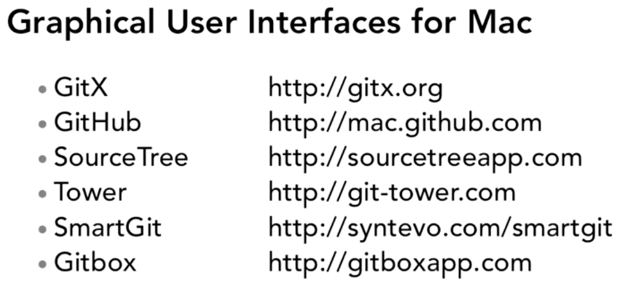

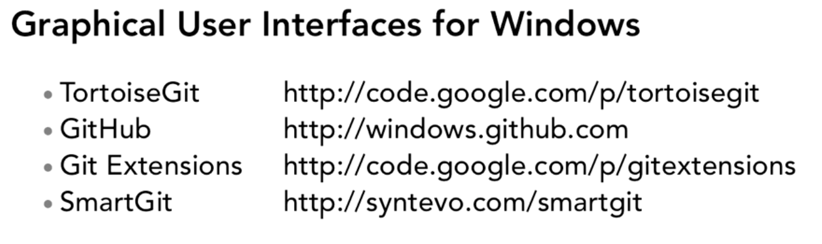

Example with GitHub (connecting one)

## Understanding Git hosting

Remote repositories that are hosted somewhere where multiple users can all have access to that one remote. A Git server needs to be set up to handle all those different users

1. Have a hosting company
   1. Example: GitHub
   2. Handle: server administration, data backups, make configuration easy, give graphical user interface,
2. Do it yourself
   1. Keeps code inside the firewall (won’t share code with third party)
   2. Use Gitolite <http://github.com/sitaramc/gitolite>

# **15.0 Assessment**

I think it’s worth trying out

|  |  |
| --- | --- |
| Positives | Negatives |
| * Track changes with messages * Keep history of changes * Sharing across web | * Doesn’t show information change in raster files * Not sure how it’s going to work with shapefiles. |

# **16.0 Resources**

Different developer tools

* <https://education.github.com/pack>
* <https://education.github.com/pack/offers>
* GitHub: <https://github.com>

Git Tutorials

* Live demo (not as helpful): <https://try.github.io/>
* <https://www.atlassian.com/git/tutorials/learn-git-with-bitbucket-cloud>
* Lynda: <https://www.lynda.com/Git-tutorials/Introduction/100222/111245-4.html>
* CodeSchool:<http://gitreal.codeschool.com/?utm_source=github&utm_medium=codeschool_option&utm_campaign=trygit>